The Sandwich exercise

Used in conjunction with the CAGED system this exercise has the very powerful effect of enabling you to find a major scale in any key, anywhere on the fretboard, in either forward or backward diagonal positions.

Once mastered with the major scale it can then also be used to learn all other scales and modes.

Start by learning these seven octave patterns:

Forward diagonals:
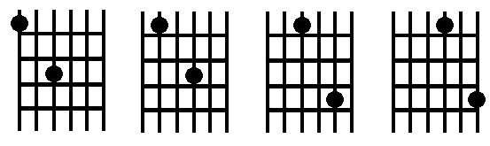

Backward diagonals:

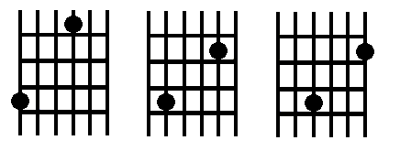

For each octave pattern:

- Play the octave (one slice of bread)
- Play the major scale up and down (the filling in the sandwich)
- Play the octave pattern again (the other slice of bread)

Note that where you drill this on the fretboard doesn’t matter - it’s which string you start each pattern on that determines the actual shapes.

For example, starting at A on the sixth string:

Forward diagonals:

e------------------------------------------------
B------------------------------------------------
G------------------------------------------------
D----7-------------4-6-7-6-4----------------7----
A------------4-5-7-----------7-5-4---------------
E--5-----5-7-----------------------7-5----5------

e------------------------------------------------
B------------------------------------------------
G----7-------------4-6-7-6-4----------------7----
D------------4-5-7-----------7-5-4---------------
A--5-----5-7-----------------------7-5----5------
E------------------------------------------------

e------------------------------------------------
B----8-------------5-7-8-7-5----------------8----
G------------4-5-7-----------7-5-4---------------
D--5-----5-7-----------------------5-7----5------
A------------------------------------------------
E------------------------------------------------

e----8-------------5-7-8-7-5----------------8----
B------------5-6-8-----------8-6-5---------------
G--5-----5-7-----------------------7-5----5------
D------------------------------------------------
A------------------------------------------------
E------------------------------------------------

Backward diagonals:

e------------------------------------------------
B------------------------------------------------
G----2---------------1-2-1------------------2----
D----------------2-4-------4-2-------------------
A----------2-4-5---------------5-4-2-------------
E--5-----5---------------------------5----5------

e------------------------------------------------
B----3---------------2-3-2------------------3----
G----------------2-4-------4-2-------------------
D----------2-4-5---------------5-4-2-------------
A--5-----5---------------------------5----5------
E------------------------------------------------

e----3---------------2-3-2------------------3----
B----------------3-5-------5-3-------------------
G----------2-4-5---------------5-4-2-------------
D--5-----5---------------------------5----5------
A------------------------------------------------
E------------------------------------------------

