1
1.0 Texas style blues – vs.1

[Nick head and shoulders]

Intro:
Great tune mixing lead and rhythm
Sounds smart but easy to learn
Here’s the end result against the BT
[Cut to Nick Plus Guitar]
Cue BTrack
Demo Texas Blues Verse 1

First look at chords
[Cut to 16to9_E7A7B7.jpg]
If you don’t already know these three then pause the video and practice them
….5 seconds or so…
[Cut to Left hand on the guitar with 16to9_E7.jpg as PIP]
Demo E7
Play E7 with this rhythm
Demo E7: / // /
In response to my playing:
Demo first lead line
…Repeat a few times
2
Now I’m going to play the same riff but ending on A to fit with the A7 chord
[Cut to Left hand on the guitar with 16to9_A7.jpg as PIP]
Demo A7
Play A7 with this rhythm
Demo A7: / // /
In response to my playing:
Demo first lead line
…Repeat a few times

Last line quick change from B7 to A7
[Cut to Left hand on the guitar with 16to9_B7A7.jpg as PIP]
Demo B7 – A7 change
In response to my playing:
Demo first lead line
…Repeat a few times

[Cut to Nick Plus Guitar]
So now let’s play the whole verse together. I’ll play the lead lines and you respond with the chords:
Demo whole verse

3
You might want to run through that a few times before moving on.

[Cut to Head and Shoulders]
Now lets look at the lead part
Here’s the TAB for the first phrase
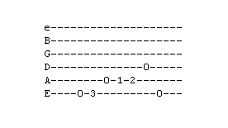
[Cut to 16to9_tabTexBlues_1.jpg]
This is played like this:
[Cut to left hand with 16to9_tabTexBlues_1.jpg as PIP]
First line up hand first three frets
One finger per fret rule
6th string open 3
5th string open 1 2
4th string open
Then 6th string open

Repeat demo

[Cut to Nick plus guitar]
Learn well because it repeats
Timing 2 & 3 & 4 & 1
4
Practice with me
Repeat demo

Rewind and repeat as often as necessary if you got that right rest will be easy.

OK next line
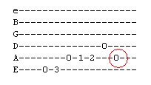
[Cut to 16to9_tabTexBlues_2.jpg]

Notice that same with different end marked red
[Cut to left hand with 16to9_tabTexBlues_2.jpg as PIP]

So this time we play the phrase as before but land on open A

This preceeds the A7 chord

[Cut to Nick plus guitar]
Demo
5
Practice a few times
Repeat demo

Now ready for first 8 bars
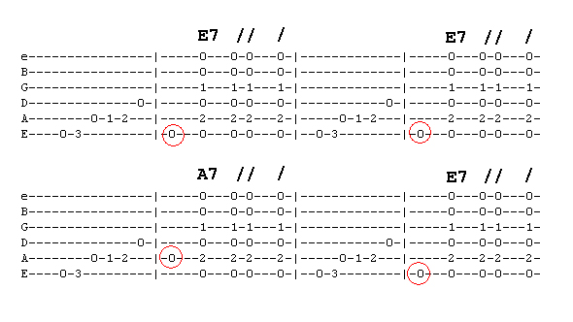
[Cut to 16to9_tabTexBlues_2.jpg]
Same phrase except for end note highlighted in red

[Cut to left hand with 16to9_tabTexBlues_2.jpg as PIP]
Demo
Have a go you play lead I’ll play chords
Repeat Demo

[Cut to Nick Plus guitar]
Now to last line
Here we play the same phrase but land on the B note fret two on A string

6

[Cut to 6to9_tabTexBlues_3.jpg]
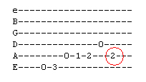
[Cut to left hand with 16to9_tabTexBlues_3.jpg as PIP]

Demo
Followed by the quick change
Demo You play/ I play

Then it’s back to phrase 1
Demo
So the whole last line
Demo

[Cut to head and shoulders]
Now ready to play lead right the way through you play/ I play let’s go!
[Cut to Nick plus guitar]
Demo
And again
Repeat Demo
7

Now you have learnt both chords and lead try putting it all together

Here’s the backing track. I’ll play through with you on the first run through then leave you to it.

Cue Backing Track

Ok any time you want to practice that you can access the backing track from the toolbox menu

Have fun with that and once you have got it down come back for the next lesson when I’ll show you how to play the next verse of Texas Blues.

================================================================

