1
0.9 How to Change Chord shapes quickly

Intro:
Learning chord takes minutes – even hours. But learning to change quickly and smoothly - many months.

For best progress – focus on changing.

Introduce G Em C D7 sequence

[Cut to 16to9_cemcd7.jpg]
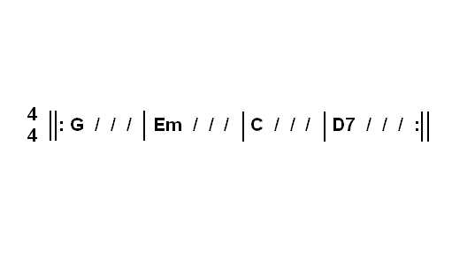
Explain 4/4 and beat marks

[Cut to PIP of 16to9_cemcd7.jpg and Nick plus guitar]

Most common mistake: four strums
2
One strum per chord is better
What’s wrong with right hand

If new to guitar here’s best approach
Look at first chord and if you don’t know it find a diagram.

Here’s a diagram of the G:
[Cut to 16to9_G.jpg]
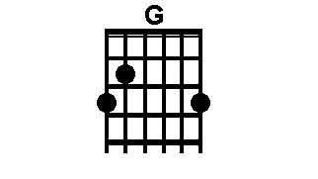
That should look and sound like this
[Cut to Nick Left hand with 16to9_G.jpg as PIP]Demo G

Once you have that down work on the next chord:
[Cut to 16to9_Em.jpg]
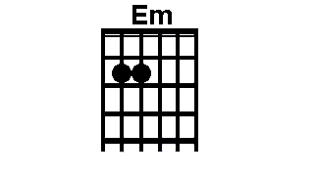
3
That should look and sound like this

[Cut to Nick Left hand with 16to9_Em.jpg as PIP]
Demo Em

Then spend time just working on the change from G to Em

[Cut to Nick Left hand with 16to9_GtoEmchange.jpg as PIP]
Demo G to Em change

Notice Common fingers (Red in diagram)

Once good at that then look at next chord:
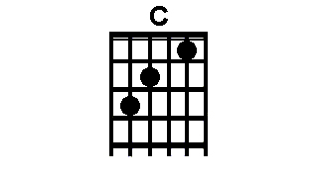
[Change PIP to 16to9_C.jpg as PIP]

Demo C

Then work on change from Em to C
4
[Cut to Nick Left hand with 16to9_EmtoCchange.jpg as PIP]
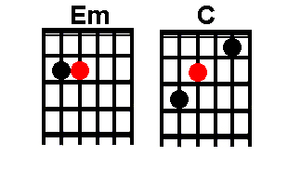
Demo Em to C change
Common note in red

Then the D7 chord
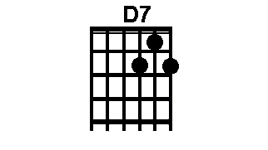
[Change PIP to 16to9_D7.jpg as PIP]
Demo D7

And once you got that, the change from C to D7
[Change PIP to 16to9_CtoD7change.jpg as PIP]
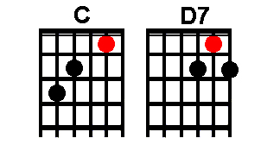
Demo C to D7 change
5

Common note in red
Then as the sequence repeats, D7 back to G
[Change PIP to 16to9_cemcd7.jpg]

Demo D7 to G change
No common note this time.
Use First finger first

[Cut to Nick plus guitar]

Once you have worked through each of these individual changes you are ready to drill the whole sequence

Start by simply hitting each chord once
Demo

Once smooth start the metronome (Toolbox to the right of the screen)
Say 60 bpm
Cue Metronome and Demo
One strum per bar

6
Play on beat one and use other three beats to change

Speed up metronome
Repeat
Once you can do this fast and smooth then slow the metronome back down to 60bpm and fill in more strums.

[Cut to Nick Head and Shoulders]
So that’s how to get on top of changes.
It takes patience and persistence, but it is a crucial part of becoming a good guitar player.

In the next lesson we’ll learn how to put it all together to accompany our first song.

================================================================

