1
4.8 Perfecting Power Chords

[Nick head and shoulders]

Power chords are great fun to get into because with just one or two shapes they give you a way of playing literally thousands of tunes across the metal, rock and grunge spectrum of guitar music.
So let’s get playing some power chords!

[Cut to nick plus guitar]
To make life easy we are going to play our first power chord high on the neck at fret 10

[Cut to left hand at 10th fret]
First finger on fret 10 on the E string.
Third finger fret 12 on the A string.
Demo
Play these two strings in one picking action like this.

2
[Cut to RIGHT hand ]
Demo
Now one problem we may have to address is that it is quite hard to hit just two strings and if we hit three or more we get a sound something like this..
Demo
To guard against this we need to go back to what we are doing with the fretting hand..

[Cut to LEFT hand ]
Demo (Explain muting)

[Cut to Nick plus guitar]
Ok, so practice getting that just right and then have a go at this little exercise to help develop the ability to move this shape around and also to strengthen and stretch the fingers.

Demo
Chromatic descent

Let’s just show you that in close-up
3
[Cut to LEFT hand ]
Demo
Stress keeping fingers behind frets.

[Cut to Nick plus guitar]
Once you have got used to that try the same shape rooted on the A string like this..

[Cut to LEFT hand ]
Demo (Stress muting 6th string as well).
Practice moving that one around as well
Demo (Chromatic descent)

[Cut to Nick plus guitar]
Often you’ll be using these two shapes in combination with each other so to prepare for that try this exercise
[Cut to LEFT hand ]
Demo
Circle of fourths descent
(Explain)

4
[Cut to Nick plus guitar]
There is one more two-note shape you may need to know about – it’s actually the easiest to play, but, because of it’s slightly less powerful sound, it is rarely used. If you want to play Smoke on the Water however then that is one song where this shape works really well!

It’s called the inverted 5th shape. We’ll explain the name in a minute but first here’s how to play it:

[Cut to Left hand]
Demo
Inverted fifths
(Explain)

[Cut to Nick plus guitar]
Finally let’s look at the three note power chord shape. Slightly more difficult, but slightly fuller sound so worth learning:
5
[Cut to Left hand]
Demo (Three note 5th chords)

[Cut to Nick head and shoulders]
Now, if you can play all those chord shapes and move them around quite easily, then you are well set up to play the rhythm parts of a whole lot of songs, particularly by bands like Metallica, Nirvana and Greenday.

[Cut to Nick plus guitar]
The last part of the lesson I thought we would just explain a little more about
what exactly a power chord is, why it’s called a fifth chord and how to work out the name of each type of power chord.

A power chord differs from other chords in that it only uses two different notes.

6
[Cut to Left hand]
Demo (Explain)

In the case of the three note chord one of these notes is doubled up – played an octave higher to thicken the sound
Demo

[Cut to Nick plus guitar]
Why Fifth chords?
The numbers used in chord symbols refer to steps on the major scale.
Here’s a typical major scale pattern on the guitar
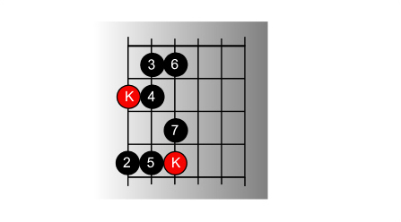
[Cut to 4_8_PowChdsMajSca_16to9.jpg]

You can see that the key note is marked in red and the rest of the notes are numbered in the order they are played.
7
[Cut to left hand with as 4_8_PowChdsMajSca_16to9.jpg as PIP]
Demo (Explain numbers)

Power chords are always made from the first and fifth notes of the major scale

Here’s a diagram showing the three types of chord shapes we have looked at in the first part of the lesson
[Cut to 4_8_PowChds_16to9.jpg]
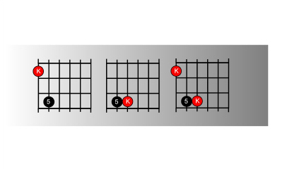
You can see that each shape uses only the Key note and the fifth note from the major scale pattern

[Cut to left hand with 4_8_PowChds_16to9.jpg as PIP]
Demo
(Explain)

8
[Cut to Nick Plus Guitar]
You can also see that the root notes of the chord are the same as the key notes of the scale they come from. Now these root notes give the chord its name so when we play this shape…

[Cut to left hand with 4_8_PowChds_16to9.jpg as PIP]
Demo (G5)
…at the third fret here we get a G Fifth chord because this root note is a G…..If I move it up a fret it becomes a G#5, A5th etc.. If you are unsure how to name these notes then check back to the chromatic scale lesson .

Notice that when we play the second shape, the root note is actually the higher of the two note we are playing –
Demo (G5 inverted)
that’s why it’s called an inverted fifth because it’s upside down.

9
That’s also why it sounds a little thinner in effect than the others.

Finally, notice that the three-note power chord shape is really a combination of the other two shapes..

Demo
(G5 three note chord)

[Nick head and shoulders]
Ok that’s all about power chords for the time being. If you’re ready to try these out and want to learn a new song then a great place to start is the version of Teenage Kicks that I’ll show you in the next lesson.

See you then!

================================================================

