1
4.7 How not to get lost on the fretboard

[Nick Head and Shoulders]
Having learnt how to get a single note to sound clean, I want to show you a simple warm-up exercise that is designed to get your fingers working together.

Later, as we learn more and more about how to find notes on the fretboard you will appreciate how starting off with this exercise prepares you for what we call ‘Positional playing’ . This is a method of finding notes in specific patterns that relate to the fret with which you line your hand up.

[Cut to left hand]
Demo

[Cut to Nick plus guitar]
Relative finger strength
Football analogy

2
[Cut to left hand]
Start by lining up the fingers of your fretting hand with frets 1 2 3 4
The important thing with the left hand is one-finger-per-fret

Demo
Play the first four notes using each of the fingers 1 2 3 4
Demo
Then go straight across from the bottom string to the top
Demo
then up a fret and back fingering 4 3 2 1
Demo

[Cut to Nick Plus Guitar]
The important thing with the right hand is
To use a consistent picking system.

If you are using a pick try all three of these methods

[Cut to Right Hand]
All down strokes:
Demo
3
All up strokes:
Demo
Alternating up and down strokes:
Demo

If beginner use the one you find easiest then work at the methods you find hardest. The alternating one is the most important.

[Cut to Nick Plus Guitar]
If you are using fingers there are several methods that are worth developing
We use the letters PIMA to refer to the right hand fingers as follows:

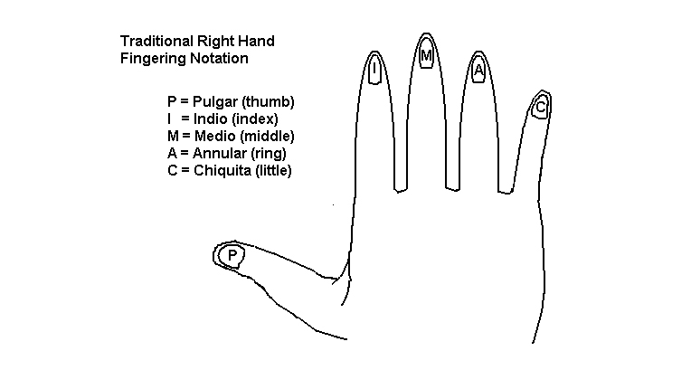
[Cut to 16to9_RHfingernames.jpg]

4
[Cut to right hand with 16to9_RHfingernames.jpg as PIP]

P on 654 and I m a on 321
Demo
P and I alternating throughout
Demo
P IMA throughout
Demo
MI ascending and IM descending
Demo
IM throughout
Demo

[Cut to Nick Plus Guitar]
Spend a bit of time getting this down
Don’t worry about doing it fast
Speed is the product

Any time you want to run through this exercise in more detail, including using the metronome to make sure you play it in time then you can access it from the Guitar Gym section of the site where it is used in the first video after the intro.

5
I’ll leave you with the tab of this basic warm-up exercise.

And look forward to seeing you in the next lesson

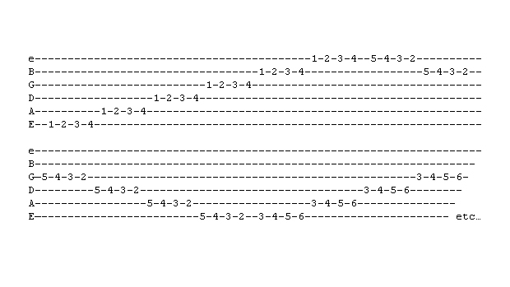
[Cut to diagram: 16to9tabnotelinking.jpg]
==============================

