1
4.4 Name that string, number that fret!

[Head and Shoulders]
Intro
The strings on the guitar are referred to in different ways, sometimes by note name and sometimes by number.
Good to get this sorted out at the outset to avoid confusion later.

[Cut to view of right hand]
Play strings and listen to them
Top string is at the bottom
Bottom string is at the top

String are numbered 1 to 6

[Cut to diagram 16to9_strngnames.jpg]
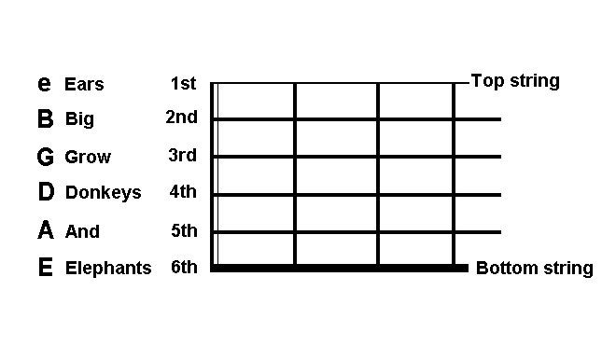

2
[Cut to Head and Shoulders]

Standard tuning
In a later lesson we’ll show you how to tune the guitar to standard tuning.

Define ‘Open String’

Once properly tuned, the notes on each open string will be:
EADGBE

Lots of ways of remembering this but my favourite, in terms of usefulness, is:

Elephants And Donkeys Grow Big Ears

[Cut to head and shoulders]
Outro
Spend a little time learning
See you in the next lesson

Cut to diagram16to9_strngnames.jpg]

===============================

