1
4.3 How to play the Amplifier

[Nick head and shoulders]
Two questions we get asked most frequently about guitar amps are:
1. How do I get a high level of sustain or overdrive from my amp without necessarily turning it up too loud and
2. What am I supposed to do with the tone or EQ controls on the amp.

In this lesson we shall address both of these subjects.

[Cut to Nick plus Amp]
First let’s look at setting up your amp to get the most sustain at reasonable volume.

Now one difficulty about discussing amplifiers is that, manufacturers differ in their choice of labels for the controls on different makes of amplifier.
One manufacturer will label a control ‘Volume’ another ‘Gain’
2
We also get ‘Boost’, ‘Level’ ‘Pre-gain’ Post-Gain’ ‘Overdrive’ ‘Distortion’ ‘Input volume’ ‘Output volume’ and ‘Master volume’ – all labels on knobs that basically do the same thing – they allow you to control the amplitude of the signal passing through the circuitry of the amplifier at some given point.

Added to this complication, some amps have multiple channels and some even multiple inputs.

Now, if you have got more than one channel or input choose one that is labelled ‘High Gain’, ‘Overdrive’ ‘Distortion’ or some such label indicating more power.

Avoid channels labelled ‘Clean’ or ‘Low Gain’

3
Now look at the control panel of your amp and locate the input socket – this should be where your guitar lead is plugged into the amp.

It is normally either to the far right or to the far left on the panel.

In a simple small practice amp you might have a layout something like this:
[Cut to 14_3_AmpCoLay1_16to9.jpg]
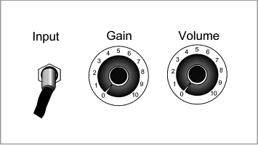
Whatever labels are used on your amp we’ll call the one closest to the input socket GAIN and the farthest one VOLUME.

If your amp has separate channels, the layout may be something like this:

4
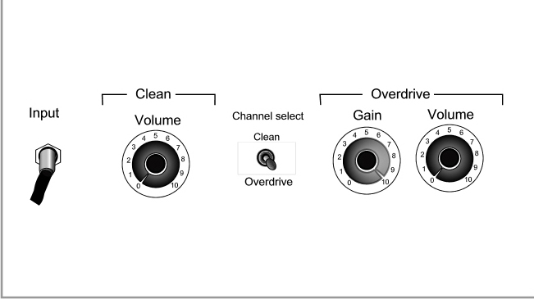
[Cut to 14_3_AmpCoLay1_16to9.jpg]

Again, whatever labels are used on your amp we’ll call the one closest to the input socket GAIN and the farthest one VOLUME.

Finally, you may have a situation where you have three controls that all affect volume on a given channel setting for example:
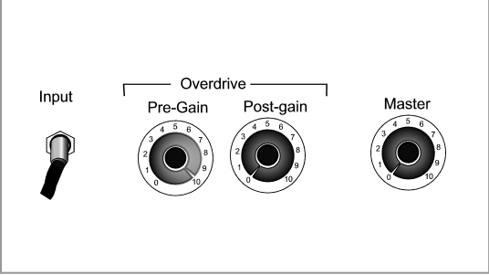
[Cut to 14_3_AmpCoLay1_16to9.jpg]

5
Whatever the layout, for the purposes of our instructions, in a case like this we will refer to the two controls nearest to the input socket as GAIN and the control furthest from the input socket as VOLUME.

[Nick head and shoulders]
Now here’s a great way to visualise how to get good sustain out of your system.
Think of washing a car with a hosepipe. If you want to blast the mud off the car what do you do?

You turn the tap on fully and get as much water pressure as possible. Then you stick your thumb over the end of the hose to restrict the flow. The combination of high pressure and the restriction of flow means you get maximum velocity and intensity out of your jet of water. That’s pretty much how those commercial water jet cleaners work – high pressure feed and restricted opening at the business end!

6
So here’s how to apply this to your amp settings.

[Cut to Nick plus amp]
First, as an important precaution, turn the Volume control (the one furthest from the input socket to zero).
Demo

Next make sure that you are feeding the amp as much signal as possible. This means TURN up all controls on the guitar to 10.
[Cut to Nick plus guitar]
That’s Volume and tone. Have as many pick-ups selected as possible and if you have any kind of active circuitry (boosters) switch it on .

[Cut to Nick plus amp]
Then, in the interests of maximising pressure, turn the gain on the amp straight up to 10. Remember if there are three controls affecting sound levels on your amp then this applies to both of the controls nearest the input socket.
7
Demo
Remember you have just created the audio equivalent of a primed and loaded bomb! With this much ‘Pressure’ in the system, the output volume control is going to be pretty sensitive so TURN IT UP S L O W L Y
Demo

[Cut to Nick head and shoulders]
So there you are – you won’t get more sustain out of your system than that!

Now here’s a good way to set the EQ.
Again amps will differ, but the vast majority will give you some control of Bass Middle and Treble.

[Cut to Nick plus guitar]
First check to see that you are sending the amp as much information to work with as possible by turning everything up on the guitar. Also make sure you have whatever pick-up selection you prefer set up on the guitar.

8
[Cut to Nick plus amp]
Next, set the volume level on the amp as high as you reasonably can, because the higher the volume the more clearly you will hear the effects of the EQ controls. If you are going to be playng clean then select the cleanest setting, if you are going for sustain then set the gain and volume according to the instructions earlier in this lesson.
Now Shut down the treble and middle controls to zero and set the bass on 10.
Test this setting by playing the lowest sounding strings on the guitar. It will almost certainly sound too boomy..

Demo
Turn the bass down until the lowest notes on the guitar sound about right.

Next turn the treble all the way up and test the highest notes you are likely to play. They will sound too tinny…
9
Demo
(Explain)
Turn the treble down until the highest notes on the guitar sound about right.

Finally, strum a chord across all six strings and feed in the middle to restore a bit of warmth and body to the sound. Too much middle can make things sound a bit thick and muffled – too little and the sound is a bit brittle or cold sounding.
Demo
(Explain)

10
[Nick head and shoulders]
Different amps have all kinds of different features. We have just covered the basic essentials that are common to most amps here.

If you have a question about how to use other settings on your amp please ask us and we’ll always be pleased to help if we can.

My best advice is to spend some time experimenting with different settings to see what you like!

Remember that the amp is part of the instrument you are playing when you play electric guitar!

Have fun with it!
See you in the next lesson.
================================================================

