1
4.2 Make friends with your Electric Guitar

[Nick head and shoulders]
This is the lesson for you if you own an electric guitar and would like to gain a bit more understanding of what all the knobs and switches do and learn a bit about how an electric guitar works.

We are going to talk in a minute about different types of electric guitar, but first let’s look at the details that affect all electric guitars.

[Cut to Nick Plus Fender Strat Guitar]

The thing that makes the difference between an acoustic guitar and an electric one is the use of pick-ups.
Demo location of pick-ups
Now a pick-up is simply a magnet with a wire coiled round it
2
[Cut to ElGtrScPu_16to9_ .jpg]
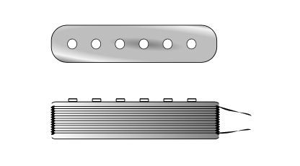

We’re used to seeing this from the top view, but if you look at the lower diagram this shows a side view and you can see the wire coiled around the magnet.

[Cut to Nick Plus Guitar]
So lets just briefly go over how the pick-up works..
When I strike a string…
[Cut to Right Hand]
Demo

It vibrates, and this vibration causes a disturbance in the pick-up’s magnetic field which triggers a tiny alternating current in the wire coil around the magnet..

3
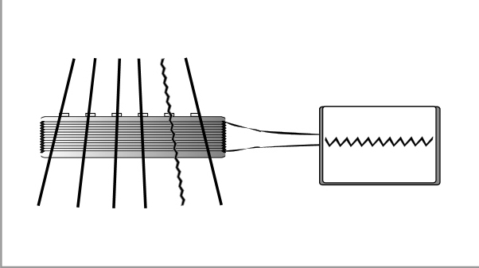
[Cut to ElGtrWorks_1_16to9_ .jpg]

This current alternates its polarity from plus to minus at the same frequency that the string is vibrating. This is how it carries information to the amplifier that defines the exact pitch and tone produced by that vibrating string.
This information travels down the wire from the pick-up as a tiny electronic signal.

[Cut to Nick Plus Guitar]
The signal then passes through the control knobs on the guitar which can be used to reduce the strength of the signal – VOLUME or the shape of it TONE.
4
[Cut to Close-up of controls]
Demo
(Explain)

[Cut to Nick Plus Guitar]
Next, the signal passes along wires to the output jack where it is transferred to the guitar lead if it is plugged in!

(If your guitar is very quiet in spite of all the controls being up to maximum the first thing to check is whether you have plugged the lead in!!)

The other thing to check is where the other end of the lead is! Ideally you want it plugged into a guitar amplifier. And then make sure the amp is switched on.

5
[Cut to Nick Plus Amp]
The word ‘amplify’ means ‘to make larger or more powerful’

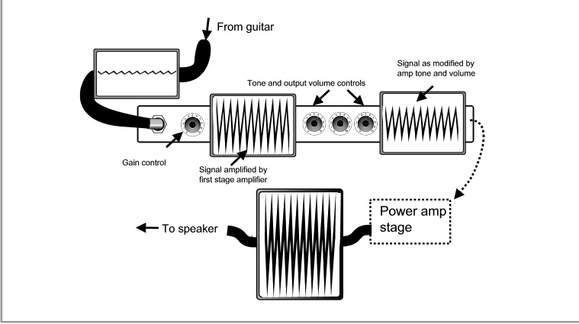
[Cut to ElGtrWorks_2_16to9_.jpg]

And you can see from the diagram that the tiny signal from the guitar goes through three distinct changes as it passes through the circuitry in the amplifier.

First it gets greatly magnified by the input stage – this is often controllable by a knob on the amp labelled either volume, gain or pre-gain.

6
Second, according to how you change the tone and controls on the amp, the shape of the signal changes. The signal is then often reduced by the output volume or master control.

Then finally the signal is converted by the power stage into an alternating electrical current strong enough to power the speakers.

[Cut to Nick plus amp controls]
Demo
(Explain)

[Cut to Nick plus amp speaker]

Think of the speaker as a sort of air pump that works in both directions – first pushing the air then pulling it – effectively creating waves that pulse at the same frequency as your vibrating guitar string.

7
These waves of air then enter your ear and trigger the same frequency of vibration in your eardrum. Nerves carry this vibration to your brain where some really clever biological software interprets this information as the note ‘A’ !!

[Cut to Nick Plus Guitar]
Now your guitar may look a bit like this one…. With three SINGLE pick-ups and a five- position selector switch.

Or it may have what are called humbucker pick-ups. They look like this…

[Cut to Nick Plus Ibanez Guitar]
Demo
(Explain)

If you were to take a humbucker pick up…

8
[Cut to ElGtrHum_1_16to9_.jpg]
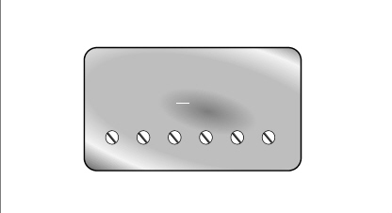
and take the lid off it you would see that underneath are two single coil pick-ups…

[Cut to ElGtrHum_2_16to9_.jpg]
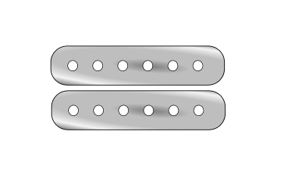

these pick-ups look identical at first glance but they are wired opposite to
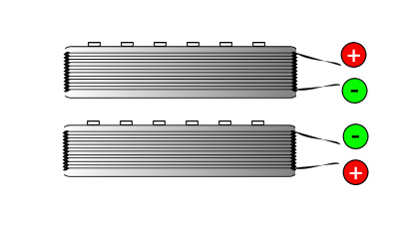
[Cut to ElGtrHum_3_16to9_.jpg]
9
each other, which has two useful effects. One it reduces the hum from electrical interference that single coil pick-ups suffer from (hence the name – hum – buckers) and secondly they put out a more powerful signal which is ideal for the strong sustained sound used for heavy metal guitar for example.

[Cut to Nick Plus Ibanez Guitar]
They also have a richer sound when used at lower power settings which is why you find them on semi-acoustic guitars like this one that are perhaps more suited to Blues and Jazz sounds.

[Cut to Nick Head and shoulders]
Now it is likely that you own one or the other of these types of guitar, but it is also possible that your guitar has a mix of pick-up types.
10
You may also have other features on your guitar like active circuitry that allows you to shape the sound in a variety of ways before it even reaches the amp.

Whatever type of guitar you own, here is a useful trick to help you get to know your guitar:

First find a screwdriver or some similar, preferably blunt metal object.
Demo

[Cut to Nick Plus Ibanez plus amp]
Then plug your guitar into the amp and then turn the amp on.
Next, make sure that the volume and gain controls on the amp are turned to low and then turn all the controls on the guitar up to maximum.

Demo
11
Now strike the strings and carefully adjust the volume on the amp to get a comfortable sound level out of it like this..
Demo

Next, locate your pick-up selector switch which will probably look either like this…

[Cut to ElGtrPSS_1_16to9_.jpg]
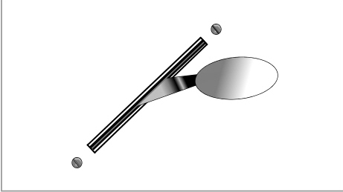

which is usually a five-position switch used on guitars with three single coil pick-ups or like this…

12
[Cut to ElGtrPSS_2_16to9_.jpg]
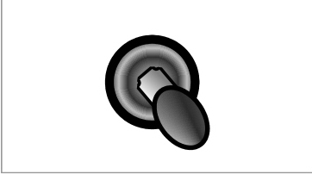

a three -position switch used on guitars with two humbucker sets.

[Cut to Nick Plus Ibanez plus amp]
Whichever type of switch you have on your guitar, switch the switch all the way in the direction of the head of the guitar and then take hold of your screwdriver and just touch the pick ups one after another. If you get a loud sound from the amp like this..
Demo

Then you know that that pick-up is selected with the switch in that position.

13
Normally this will be the neck pick-up position but guitars can vary.

Then switch to the next position and test each pick-up again.
Demo
In this position you will almost always find two pick-ups selected.

Demo
In the next position you will normally be back to one pick-up – either the middle one (if three) or the bridge one (of two)

[Cut to Nick Plus fender plus amp]
If you have five positions, continue to the next setting which will probably pair the middle and bridge pick-ups together
Demo
and the final one which will select just the bridge pick-up.

14
Don’t worry if you get different results as different guitars are wired differently. The important thing is to use this trick to figure out which pick-ups are selected with which switch setting.

[Cut to Nick Head and shoulders]
Now once you have established the pick-up selector settings you can more easily work out what the remaining controls do.

[Cut to Nick Plus fender plus amp]
So with my neck pick-up selected I can now see how the volume control affects things.
Demo
In this case – pretty straight forward – as there is only one volume control on this guitar it tends to have the same effect no matter which pick-ups are selected.

15
And each of the tone controls..
Demo

This tone control seems to have some effect… whereas this one doesn’t so we can assume that this tone control is wired to this pick-up, but this one isn’t.

Now I select just the middle pick-up
Demo
And try the tone controls and we can see that this time it’s the other way round
Demo
Finally I select the bridge pick-up on it’s own and discover that it is unaffected by the tone controls on this model of guitar.

16
[Cut to Nick Head and shoulders]
So now we know which pick-ups are affected by which tone controls there’s one last thing to check out and that is what sort of sound each pick-up and combination of pick-ups produces.

[Cut to contols close-up on fender guitar]
With the volume and tone up full on the guitar and

[Cut to contols close-up on amp]
the amp set up with all tone controls on neutral (5) position.

[Cut to Nick Plus fender guitar]
First select the neck pick up and strum the strings and listen to it.
Demo

Then select middle and listen to it.
Demo
Then bridge pick-up and listen
17
Demo
You can here the sound gains in treble and loses bass as we progress from neck position to bridge.

Now select the neck and middle combined. And you can hear a fatter sound.
Demo
On this type of guitar this is achieved by the wiring of each of any pair of pick-ups being opposite. This produces signals that are out of phase with each other in a similar way to how humbucker pick-ups work.
[Cut to Nick Head and shoulders]
Now electric guitars can have many different features, but once you have worked out your pick-up selections and got a feel for the different sounds you get from different combinations the rest is usually pretty self-explanatory.

18
If you have any specific questions about your own guitar that remain unaddressed, after going through this video, then please use the ‘Ask a question’ link above and to the right of this screen.

Ok – if you have enjoyed learning about the electric guitar then join me again in the next lesson which is called:

‘How to play the Amplifier’

and will answer all your questions about how to get the different sounds out of your amp.

See you then!
================================================================

