1
4.1 Beginner’s Acoustic Guitar Course - Introduction

[Nick head and shoulders]

Welcome to the SecretGuitarTeacher’s beginner’s course for Acoustic Guitar!

Usually we talk about pre-requisites
No pre-requisites
Got a guitar and ready to go

Instead talk briefly about what this course covers and what you can expect to be able to do by the end of it

[Cut to Nick Plus Guitar]
First two lessons cover orientation
Names of parts of the guitar
Names and numbers of strings and frets
Also how we refer to your fingers

Then lesson three gets down to the real nitty gritty of how to make clean sounding notes

2
[Cut to Nick Plus Guitar]

Demo
(Explain)

[Nick head and shoulders]
Lesson 4 tackles tuning the guitar by the basic manual method

[Cut to Nick Plus Guitar]

Demo
(Explain)

[Nick head and shoulders]
Lesson 5 gets you started on how to read guitar tab

[Insert BgAcIntTab_1_16to9.jpg as PIP]
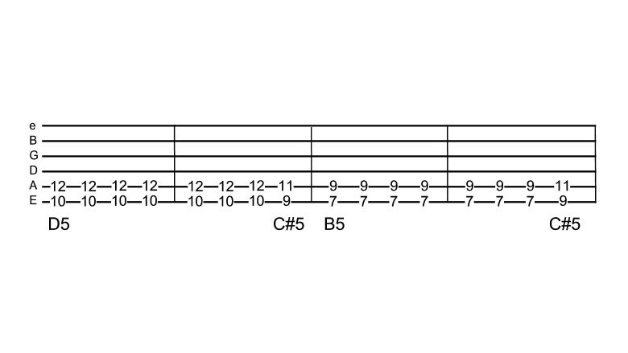

3

Allows access to the millions of songs available on internet guitar tab sites

Enables you to read the supporting printouts on this site

[Cut to Nick Plus Guitar]
Lesson 6 teaches you to link notes together
Exercise to lay foundations of good lead guitar technique and proper coordination between right and left hands

[Cut to left hand]
Demo
(Speed dev exercise)
[Cut to RIGHT hand]
Demo
(Speed dev exercise)

4
[Cut to Nick Plus Guitar]
Lesson 7 gets you playing the beginners boogie
Fun tune that’s nice and easy

Demo
Lesson 8 is all about chords and how to read different types of chord diagram

[Cut to left hand]
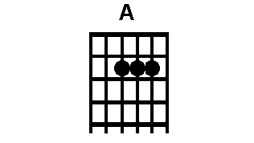
[Insert BgAcIntChd_1_16to9.jpg as PIP]

Demo
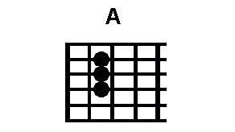
[Insert BgAcIntChd_2_16to9.jpg as PIP]

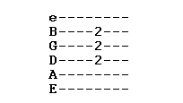
[Insert BgAcIntChd_3_16to9.jpg as PIP]

5
[Insert BgAcIntChd_4_16to9.jpg as PIP]
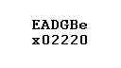
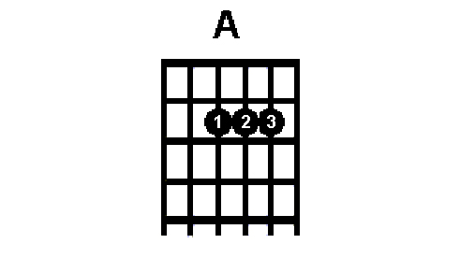
[Insert BgAcIntChd_5_16to9.jpg as PIP]
Demo
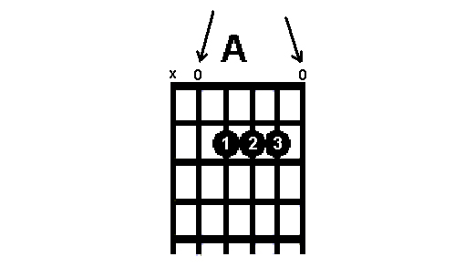
[Insert BgAcIntChd_6_16to9.jpg as PIP]
Demo
[Insert BgAcIntChd_7_16to9.jpg as PIP]
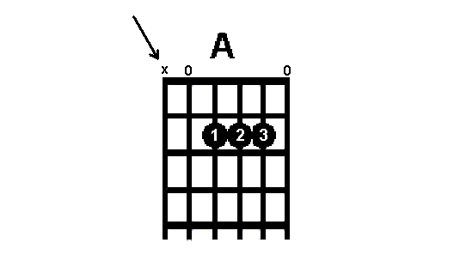
Demo

6
[Nick head and shoulders]
Then once you are comfortable playing two or three different chord shapes from diagrams,

Lesson 9 covers the all-important subject of how to change quickly from one chord to another

[Cut to left hand]
Demo
G Em C D7

Includes how to use the metronome to develop good time-keeping from the outset.

Demo
G Em C D7 with metronome

7
[Nick head and shoulders]

So in less than 10 short lessons we will have covered everything necessary to start playing along to some great songs.

The last part of the course covers specific step by step instruction on how to play along to six different classic songs starting with Knocking on Heaven’s door
[Cut to Nick Plus Guitar]
Demo
Stand by me
Demo
I‘m a believer
Demo inc intro
Then progressing to the slightly trickier Brown-eyed Girl
Demo
Inc intro

8
And a couple of blues based hits
Boots
Demo inc intro

And stuck in the middle with you
Demo inc intro

[Nick head and shoulders]

So by the time you get to the end of this little course you will be able to play in quite a wide variety of styles already.
We have deliberately mixed up the strumming patterns and thrown in a few intro riffs so that you get a chance to use all the basic skills developed in the first part of the course.

9
[Nick head and shoulders]
Each lesson is based on a short video demonstration of all the key techniques.
The important thing is to work through these videos at your speed.
Use the pause and rewind mechanism to repeat each exercise until you are ready to move on.

[Nick head and shoulders]

The video content is supported by printouts available from the toolbox

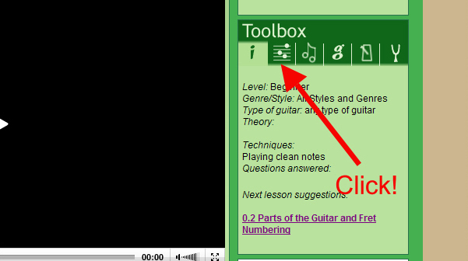
[Cut to BgAcIntScSt_1_16to9_ .jpg]

and some lessons also utilise backing tracks that you can access by clicking on the next tab along..

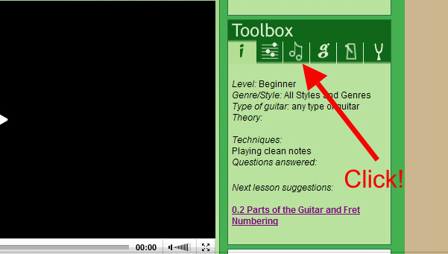
[Cut to BgAcIntScSt_2_16to9_ .jpg]

[Nick head and shoulders]
Finally, we do all we can in the design of these lessons to anticipate every question or problem that each individual student may have, but of course we know this is impossible.

So please, if you have any difficulties at all following this course or any questions that the materials don’t seem to answer just post us your problem using the Ask a Question Link in the members section just above the toolbox

10
[Cut to BgAcIntScSt_3_16to9_ .jpg]
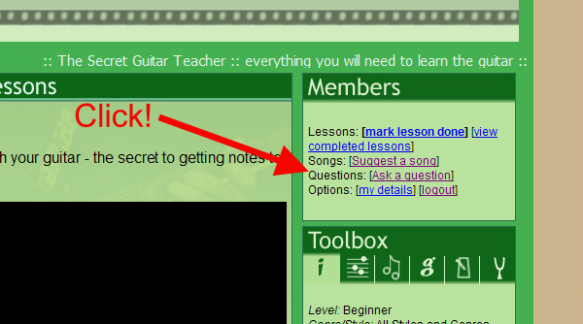
[Nick head and shoulders]
We are always happy to hear from you and we rely on your feedback to help make the site the best possible place on the web to learn guitar!

OK let’s get started!

See you on the course!

================================================================

