1
4.0 Easy Acoustic Songs – Brown-Eyed Girl
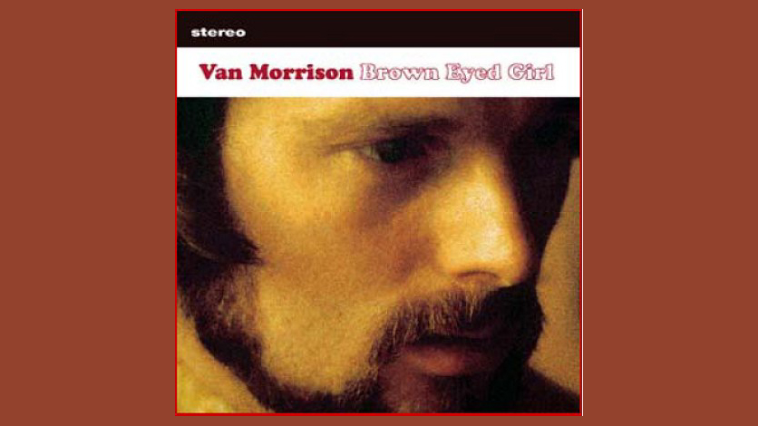
[Open with 16to9_BrownEyedGirl.jpg]

[Attach soundfile: SGT_SampleBrownEyedGirl.mp3.wav]

[Nick head and shoulders]
- First recorded in 1967
- Van Morrison’s first solo recording
- Probably the song most associated with him
- Popular sing along
- At end of lesson we’ll look at intro
- But first the main rhythm part:

To play it you’ll need just four chords

G
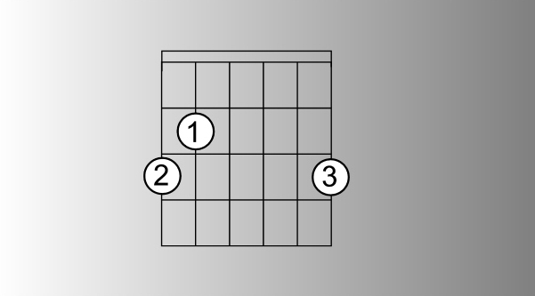
[Cut to 16to9_Gwithfingnums.jpg]
2
[Cut to left hand with 16to9_Gwithfingnums.jpg as PIP]
Demo
C
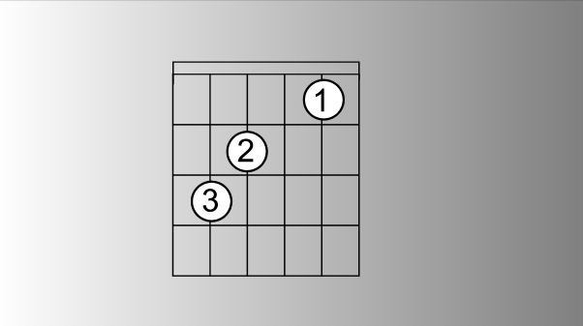
[Cut to 16to9_Cwithfingnums.jpg]

Demo
D
[Cut to 16to9_Dwithfingnums.jpg]
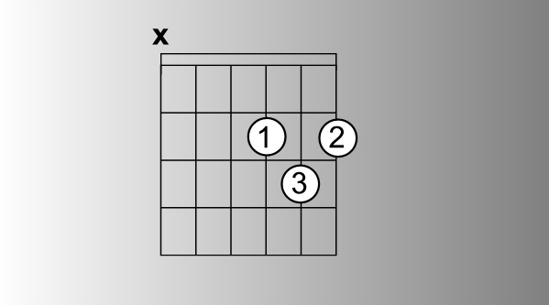

Demo
And an occasional appearance from Em
[Cut to 16to9_Emwithfingnums.jpg]

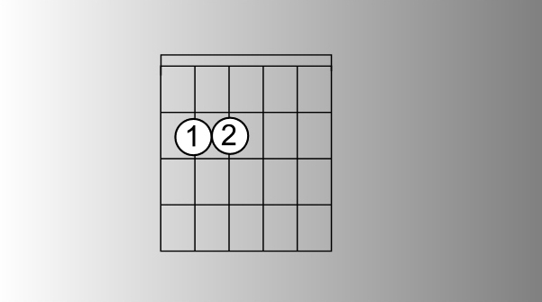
Demo
3

[Cut to Nick Plus Guitar]
Most of the song is a repeated four bar sequence: G C G D
Demo
These chords change pretty fast so First job is to get those changes up to speed
Best one hit on each chord like this:
Demo

[Cut to Head and shoulders]
Now, to be honest, once you are on top of these changes there is little about the other chord changes that’s going to trouble you in this song.
So let’s concentrate on the strumming.
First thing to say about this is that it wants a steady 8-beat feel:
[Cut to RIGHT hand]

Demo(Explain)
Then make a point of strengthening the first beat of the bar and thinning out the rest a little like this:

Demo(Explain)

4
[Cut to Nick Plus Guitar]
That’s a perfectly workable approach for beginners or near beginners, but if you have been playing a while and want something that sounds a little more like the calypso beat that is used on the original you have to emphasise the second up beat:

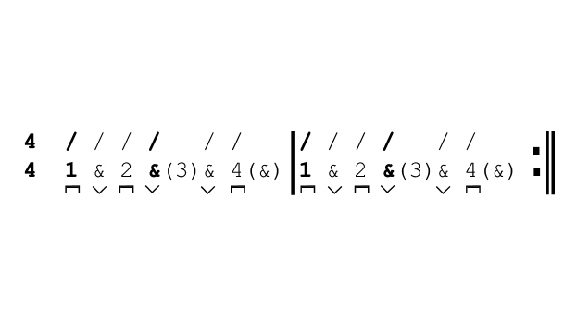
[Cut to 16to9_browneyedstrumpat.jpg]

[Cut to RIGHT hand with 16to9_browneyedstrumpat.jpg as PIP]

Demo (Explain – best done by ear)

5
[Cut to Nick Plus Guitar]
just practice playing through about 12 bars of those changes. I’m going to use the calypso rhythm, but you can choose just to keep the eight beat pattern going if you prefer or even just join in on the first beat of each bar. 1 + 2 + 3 + 4 +
Demo
[Cut to Head and shoulders]
Time to look at the layout of the song. Click the printouts tab on the toolbox to the right of this screen to open the printout of the rhythm chart. You’ll see it looks quite complex, but if we take it a step at a time it’s quite a simple song to follow:
Let’s home in on the intro:

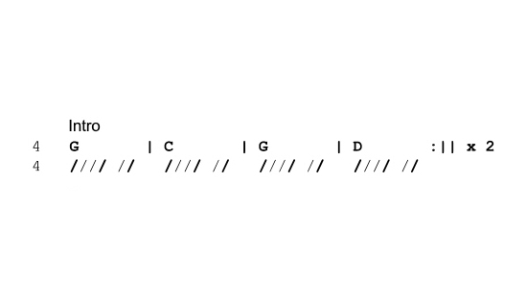
[Cut to 16to9_browneyedIntro.jpg]

You can see this is just the basic sequence played through twice.
6
[Cut to Nick Plus Guitar with 16to9_ browneyedIntro.jpg as PIP]]
Demo
There’s a nice riff that is played over this on the original that we are going to show you later in this lesson, but if you are accompanying someone else playing that – you would play the chords as shown but probably just cut off all but the first beat of the bar like this:

Demo (Hum intro riff)

[Cut to Nick Plus Guitar]
Onto the verse

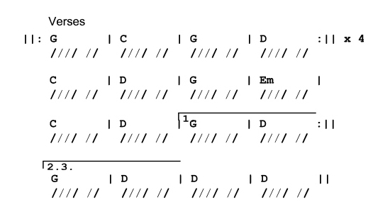
[Cut to 16to9_ browneyedVerses.jpg]]
See that we carry on with the intro chords played through 4 times ..
7
[Cut to Nick Plus Guitar]
Demo (with vocals)
Then as the vocals cue you into the refrain ..and you my brown eyed girl..
We come back to the C chord..
[Cut to 16to9_ browneyedrefrain.jpg]
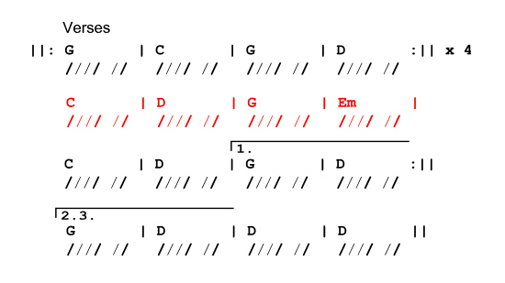

[Cut to Nick Plus Guitar with 16to9_ browneyedrefrain.jpg as PIP]

Demo
(with vocals)…followed by D G and Em

Then C and D again at which point we arrive at a decision point.

If this is the first time (first verse) that we have got here we take option 1.

8
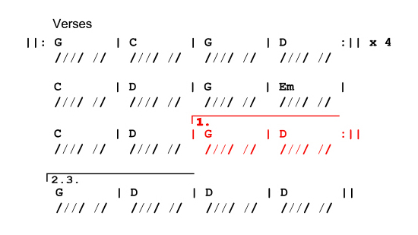
[Cut to 16to9_ browneyedend1.jpg]

[Cut to Nick Plus Guitar]
Demo (with vocals)
One bar of G followed by a D to lead us straight back into verse 2.
Then at the end of verse 2 we ignore the instructions under the number 1 bracket

[Cut to 16to9_ browneyedend2.jpg]
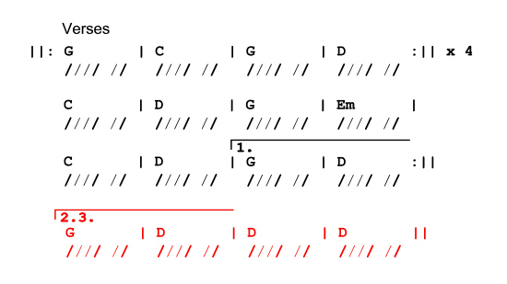

…and follow the second ending instead marked with a bracket showing 2 and 3 because it is used the third time we arrive at this point.You can see it’s the same as the first ending but with two extra bars of D
9
[Cut to Nick Plus Guitar]

This supports the bit of vocal build-up that leads into the chorus..
Demo

Do you remember when … we used to ..
Sing
Repeat Demo as necessary

[Cut to Nick Plus Guitar]
The chorus is easy to play because the chords are again the same as the intro sequence.
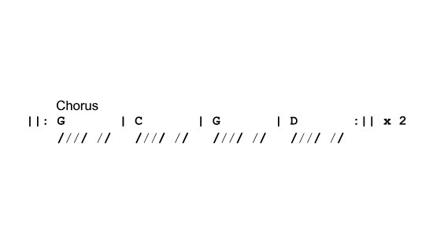
[Cut to 16to9_ browneyedchorus.jpg]

[Cut to Nick Plus Guitar]

Demo (Vocals) Sha la la ..etc

10
[Cut to Head and Shoulders]
On the original recording instrumental with a short bass solo. Several options depending on the situation you are going to be in when you are playing the song.

Simplest option and if you are just learning the song for fun and playing it by yourself is to ignore the solo and carry straight on with verse 3.

If you’re in a band and the bass player is taking the solo you would follow the chords as laid out for this section…
[Cut to 16to9_ browneyedbasssolo.jpg]
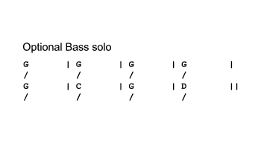
.. on the rhythm chart but play them pretty
minimally to allow the bass to take the limelight.. like this

11

[Cut to Nick plus guitar with 16to9_ browneyedbasssolo.jpg as PIP]
Demo(Explain)

.. a third approach for the more experienced guitarist is to play your own version of the instrumental section that emulates the bass solo. Maybe like this..

Demo (Explain)

[Cut to Head and Shoulders]
OK – just to wrap up then .. the song then goes into a third verse with the same ending as the second, leading into a final chorus.

Before we play through the whole song by way of a final demo let’s have a quick look at the intro riff.

12
[Cut to 16to9_ browneyedintroriff.jpg]
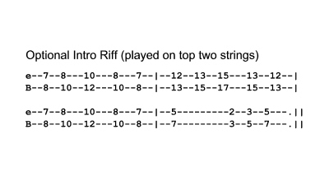

You can see that this is played on the top two strings only as a series of two note chords or double stops as they are called

[Cut to Right Hand with 16to9_ browneyedIntroRiff as PIP]
On the right hand you can use either pick or thumb and forefinger or index and middle:
Demo (Explain)

Here’s the left hand view
[Cut to Left Hand with 16to9_ browneyedIntroRiff as PIP]

Demo
(Explain)

13
[Cut to Head and Shoulders]

Time for full performance.

If you want to follow I suggest printing off the rhythm chart.

I’m going to play the intro bit and take the solo when it comes along. You are welcome to join in either just with the chords or the lead bits as well.

OK we’ll play out with this now and I’ll See you next lesson!

1 2 3 4

Demo performance

Intro/Vs1/ Vs2/Ch/Solo/ Vs3/Ch/End

================================================================

