1
3.9 Easy Acoustic Songs – I’m a Believer

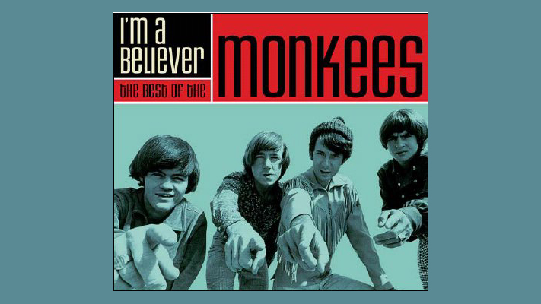
[Open with 16to9_imabeliever.jpg]

[Attach soundfile: SGT_SampleImABeliever.mp3]

[Nick head and shoulders]

- Written by Neil Diamond
- Monkees released late 1966
- Best selling single of 1967
- Shrek movie

Nice easy song for beginners

Original recording closer to Ab
Here are the chords:

First chord is A

2
[Cut to 16to9_awithfingnums.jpg]
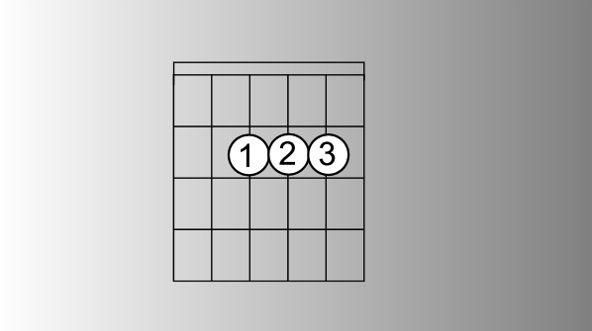

[Cut to left hand with 16to9_awithfingnums.jpg as PIP]

Demo alternate fingerings

Then E major

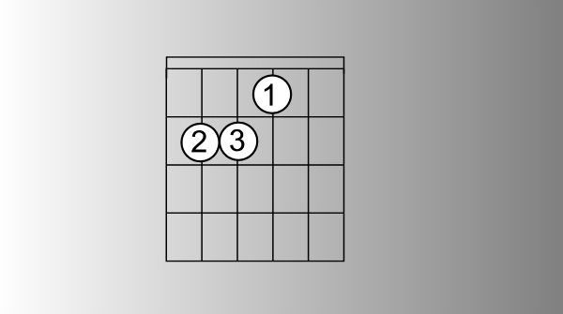
[Cut to 16to9_Ewithfingnums.jpg]

[Cut to left hand with 16to9_Ewithfingnums.jpg as PIP]

Demo

Then D
[Cut to 16to9_Dwithfingnums.jpg]
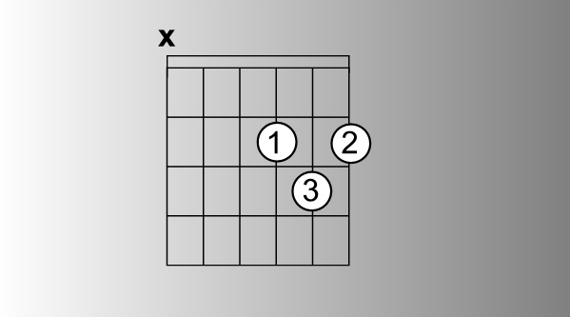
notice the x
3

[Cut to left hand with 16to9_Dwithfingnums.jpg as PIP]
Demo

And a brief appearance by G

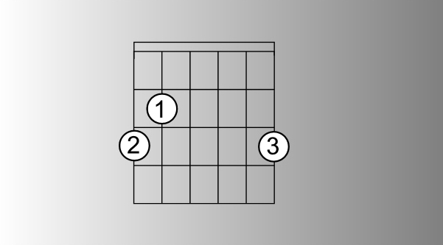
[Cut to 16to9_Gwithfingnums.jpg]

[Cut to left hand with 16to9_Gwithfingnums.jpg as PIP]

Demo

[Cut to Nick Plus Guitar]
So make a point of learning those shapes and getting used to changing from one to another. If any one chord is proving difficult then just alternate it with each of the others. Supposing the A is a bit awkward:

[Cut to left hand]
Demo
A E A D A G etc over and over until its easy.
4
[Cut to Nick Plus Guitar]
you’ve done that take a look at the sequence:

[Cut to 16to9_ImABelieverSeq1.jpg as PIP]
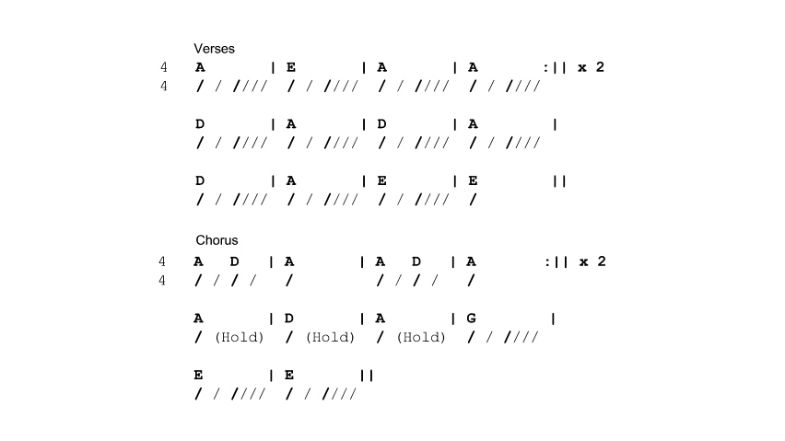

[Cut to Nick Plus Guitar with 16to9_ImABelieverSeq1.jpg as PIP]
This looks pretty complicated and it’s often true that songs can look a lot harder to play on paper than they are in reality. Trick is to take one chunk at a time. Let’s start with the first line of the verse. And let’s just look at the chords – we’ll come back to the strumming pattern later.

5
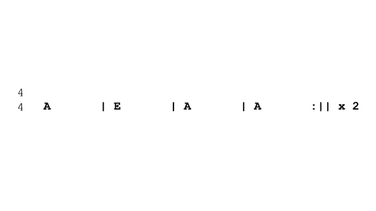
[Cut to 16to9_ImABelieverSeq2.jpg as PIP]
That already looks better doesn’t it!?

First concentrate on left hand so just hit one strum per bar like this:

[Cut to left hand with 16to9_ ImABelieverSeq2.jpg as PIP]

Demo
(Notice the repeat ..)

OK easy enough? Let’s move on to second half of the verse..

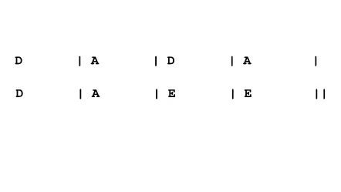
[Cut to16to9_ ImABelieverSeq3.jpg as PIP]
Notice that the change from D to A repeats – we play that three times before ending the verse on two bars of E. Like this..
6
[Cut to left hand with 16to9_ ImABelieverSeq3.jpg as PIP]

Demo

[Nick head and shoulders]
So once we are comfortable working through the chord changes for each section of the verse we can put it together and take note of the strumming pattern which we can see marked in diagonal slashes under the chords..

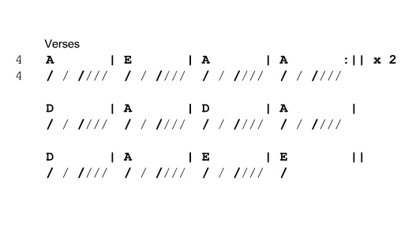
[Cut to 16to9_ ImABelieverSeq4.jpg ]
This is the same pattern right the way through the verse until the last bar.. With four beats to the bar we’ll need to use a combination of up and down strokes for this pattern like this…

7
[Cut to 16to9_ ImABelieverStrumpat1.jpg ]
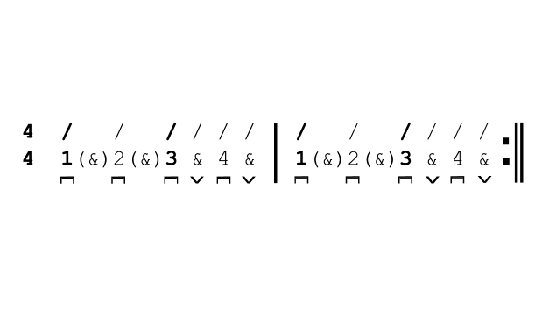
[Cut to left hand with 16to9_ ImABelieverStrumpat1.jpg as PIP]

Demo
(Talk through)

[Cut to Nick Plus Guitar]

OK so once you have got used to that pattern and can keep it going without thinking about it see if you can impose the chord changes on it like this..

[Cut to Nick Plus Guitar with 16to9_ ImABelieverSeq4.jpg as PIP]

Demo
8

[Cut to Head and Shoulders with 16to9_ ImABelieverSeq4.jpg as PIP]
Notice the last bar has only one down stroke in it. This is a kind of rhythmic set-up for the entry into the chorus and it’s done by hitting the chord and then relaxing the hand to stop the sound dead like this…

[Cut to left hand]
Demo

[Nick head and shoulders]
Now a lot of beginners agonise over strumming patterns. Don’t get too focused on it. The important thing is a relaxed rhythmic flow think of letting your hand dance along to the music..

[Cut to RIGHT hand]
Demo
And explain various patterns work, continuity etc..

9
[Nick head and shoulders]
Practice the verse until happy you’ve got it. Now let’s look at the chorus. Starts like this…

[Cut to 16to9_ ImABelieverSeq6.jpg ]
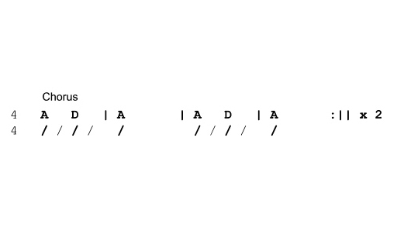
We can see that this is made up of a single idea played four times. A D A played all with down strokes like this..

[Cut to Nick plus guitar with 16to9_ ImABelieverSeq6.jpg as PIP ]

Demo

Have a go through that a few times

[Cut to Nick plus guitar]
Here’s the last part of the chorus:

10
[Cut to 16to9_ ImABelieverSeq7.jpg]
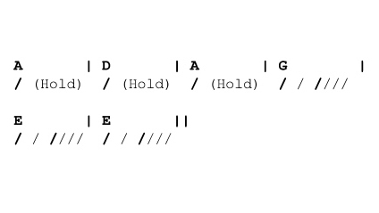
First three bars we again have just one downstroke but this time we are asked to hold the sound so instead of relaxing the hand to cut the sound of the chord off we keep the chord firmly held down so it rings for the whole bar like this…

[Cut to Left Hand]
Demo hit and hold

[Cut to Nick plus guitar with 16to9_ ImABelieverSeq7.jpg as PIP]
First three bars are played like that then we get back into the main strumming pattern for the rest of the chorus..

Demo

11
[Cut to Head and Shoulders]

There’s one optional extra with this lesson and that’s the bit of lead guitar at the intro and in between chorus and vss.
Basically it replaces the E chord:
[Cut to left hand]
Demo
Explain

[Cut to Head and Shoulders]
Performance time. Make sure you have nailed each separate part before you try to put it all together..

Play out with the whole song now – feel free to play along with me whether you’re still working at the one strum per bar level or have got the whole strumming pattern smoothed out. I look forward to seeing you in the next lesson!

[Cut to Nick Plus Guitar]
Demo song
Vs Ch Vs Ch END
================================================================

