1
3.8 Easy Acoustic Songs – Stand By Me

[Open with 16to9_standbyme.jpg]
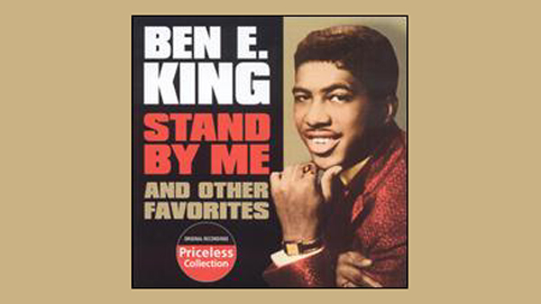
[Attach soundfile: SGT_SampleStandByMe.mp3]

[Nick head and shoulders]
Ben E King apparently recorded this song just to fill in a bit of spare studio time … amazing how often such songs become classics!

- Hit when first Released in 1961
- Film 1986 Stand By Me
- River Phoenix, Richard Dreyfuss and Kiefer Sutherland – brilliant film!
- Also featured in Levi Ad

2
[Cut to Nick Plus Guitar]

In key of A, but much easier to play in G. Capo at fret 2 to play along with record.

So first chord is G
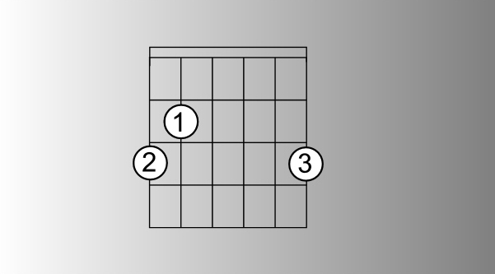
[Cut to 16to9_gwithfingnums.jpg]

[Cut to left hand with 16to9_gwithfingnums.jpg as PIP]

Demo

Then Em

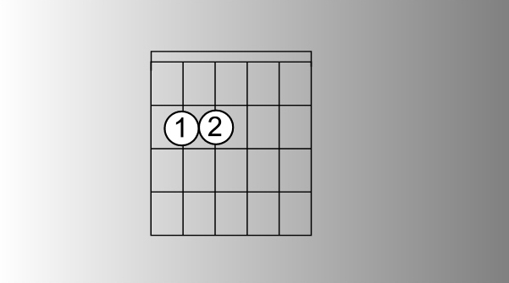
[Cut to 16to9_Emwithfingnums.jpg]

[Cut to left hand with 16to9_Emwithfingnums.jpg as PIP]

Demo

Then C

3

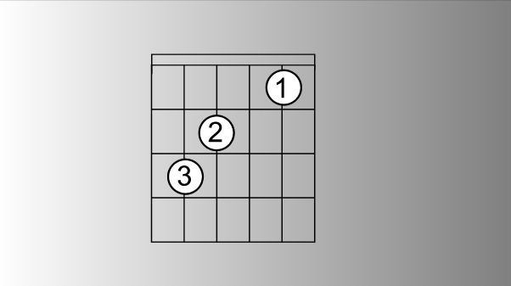
[Cut to 16to9_Cwithfingnums.jpg]

[Cut to left hand with 16to9_Cwithfingnums.jpg as PIP]

Demo

And finally D7

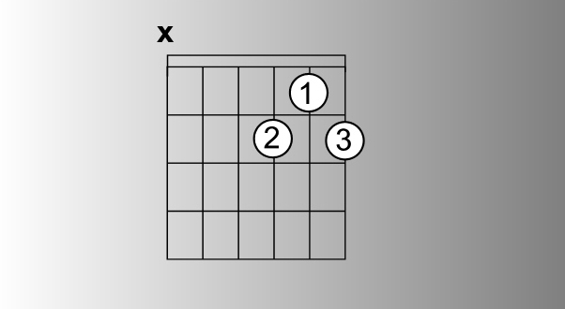
[Cut to 16to9_D7withfingnums.jpg]

[Cut to left hand with 16to9_D7withfingnums.jpg as PIP]

Demo

It works equally well with D instead of D7. I favour D7 because it slightly easier to change to from C

Demo

4
[Cut to Nick Plus Guitar]
So make sure you know each of those chords and can shift easily from one to the next in that order

Demo
G Em C D7

[Cut to Nick Plus Guitar]
Once familiar with the shapes lets look at the sequence
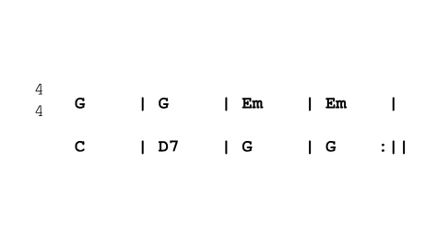
[Cut to 16to9_standbymesequence.jpg]

Notice:
Two bars of G
Two bars of Em
One of C One of D7
Two of G
5
[Cut to Nick Plus Guitar]
Follow along with me.
If beginner strum once per bar
(Strumming pattern later).

Like this…

[Cut to left hand with 16to9_ standbymesequence.jpg as PIP]]

Demo
One strum per bar

[Cut to Nick Plus Guitar]
The same sequence is used for both verse and chorus. A common problem is the four bars of G – two at end, two at beginning.
Demo
Four bars of G

[Cut to Nick Plus Guitar]
Practice that until you’re happy that your left hand is coping with changes ok

6
[Nick head and shoulders]
Now onto the strumming pattern:
This is a song that beginners can find surprisingly tricky so lets build the pattern a layer at a time.

First we need to establish an underlying 8-beat feel like this:
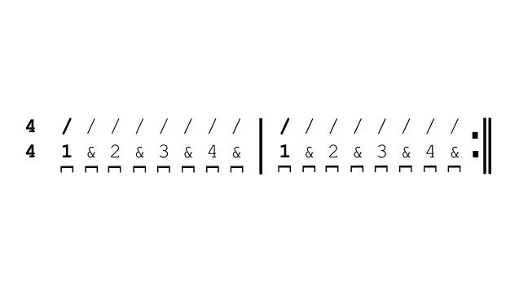
[Cut to 16to9_ standbymestrumpat1.jpg]
Although 4/4 includes half-beats in the count so that for each bar we hit 8 downstrokes.

Beats shown diagonal slashes
Count by the numbers 1 & 2 &….
Symbol on the bottom line = DOWN strokes.
So this looks like this:

7
[Cut to RIGHT hand with 16to9_ standbymestrumpat1.jpg as PIP]

Demo

[Nick head and shoulders]
Once you have practiced that enough to get it smooth try imposing the chord sequence on the same pattern like this:

[Cut to Nick Plus Guitar with 16to9_standbymestrumpat1.jpg as PIP]

Demo

Once down easily - may take a few hours of practice – add an extra accented beat on the & that comes after the 2 like this:

[Cut to 16to9_ standbymestrumpat2.jpg]
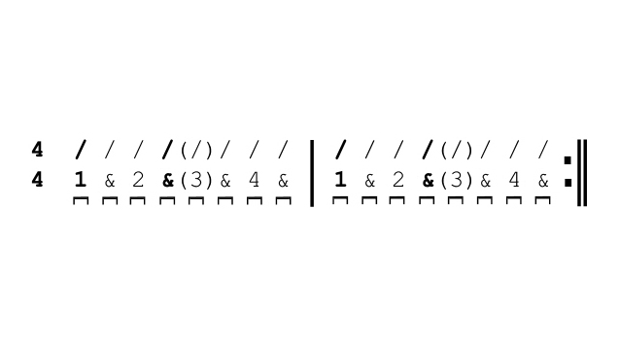

8
Notice that the fourth diagonal slash is in bold meaning that we emphasise this beat.

Because we tend to do this by making the hand travel further to include more strings, for most people learning this song, you will need to miss the next beat to give your hand time to travel back again. That is why the 3rd beat is in brackets. Let’s show you what I mean:

[Cut to RIGHT hand with 16to9_ standbymestrumpat2.jpg as PIP]

Demo
(Explain)

[Nick head and shoulders]
Now, that is a perfectly workable strum pattern for this song, but for perfectionists, I suggest that after practicing this one a while, try to put that beat number three back in place like this:

9

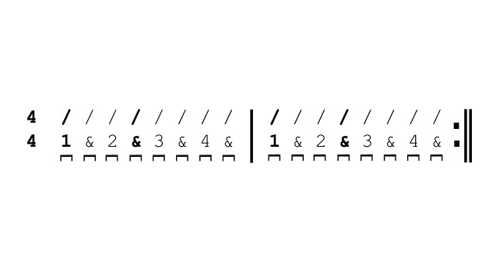
[Cut 16to9_ standbymestrumpat3.jpg as PIP]
[Cut to RIGHT hand with 16to9_ standbymestrumpat3.jpg as PIP]
Demo
(Talk through)

[Nick head and shoulders]
OK now it’s performance time. Whatever level you have got this going at whether just one strum per bar or the tricky offbeat emphasis pattern that we have just demonstrated you can play along.

Going to play out with this now. I will sing the song to help guide you through it – but I have to say Ben E King is a truly great singer - you’re going to quickly realise why I teach guitar and not vocals!
See you again soon! Performance
================================================================

