1
3.7 Easy Acoustic Songs – Knocking on Heaven’s Door

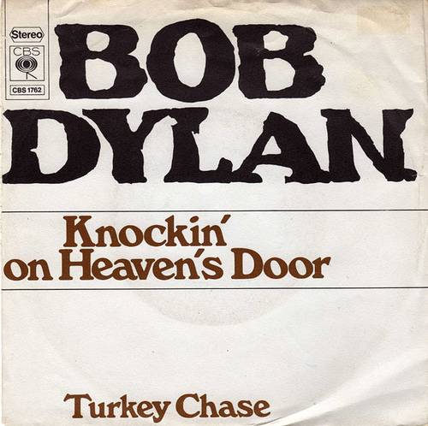
[Open with Knocking_on_Heavens_Door.jpg]

[Attach soundfile: SGT_Sample_KnockingOnHeavensDoor.mp3]

[Nick head and shoulders]

Intro:
- Bob Dylan
- Soundtrack
- Sam Peckinpah’s
- Pat Garrett and Billy the Kid
- 1973
- over 100 covers since
- Including Guns n Roses

First we’ll just go over the chords then we’ll look at a strumming pattern before putting the whole song together.

The first chord is G
2
[Cut to 16to9_Gwithfingnums.jpg]
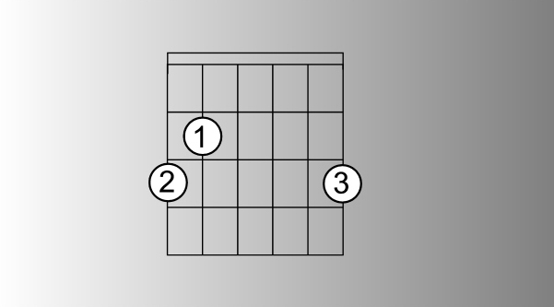

There are a few possible fingerings for a G chord – if you can go for this one – it’s the most versatile.

[Cut to left hand with 16to9_Gwithfingnums.jpg as PIP]

Demo

Then D

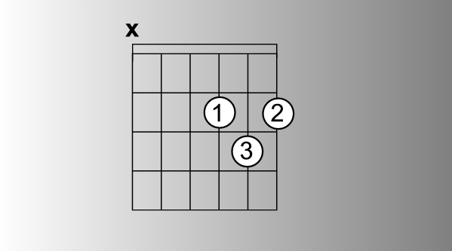
[Cut to 16to9_Dwithfingnums.jpg]

Notice the x on the 6th string

[Cut to left hand with 16to9_Dwithfingnums.jpg as PIP]
Demo
Then Am

3
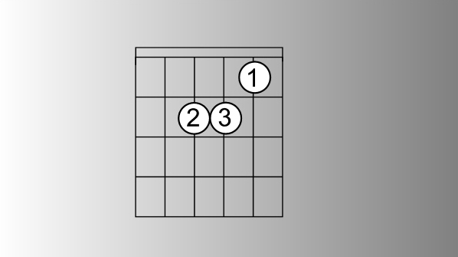
[Cut to 16to9_Amwithfingnums.jpg]

[Cut to left hand with 16to9_Amwithfingnums.jpg as PIP]
Demo

And C
[Cut to 16to9_Cwithfingnums.jpg]
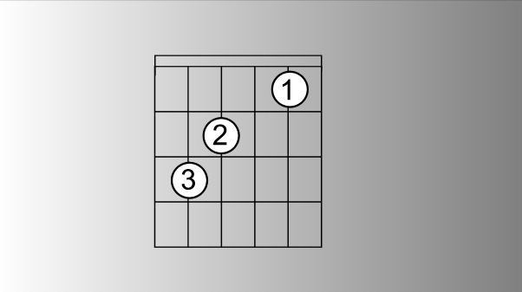

Again you may see other versions of this chord.
[Cut to left hand with 16to9_Cwithfingnums.jpg as PIP]
Demo

[Cut to Nick Plus Guitar]
When learning a new song it’s a good idea just to start by holding down each shape and doing your best to make sure you can remember the name of each chord.

Demo
G … D … Am … C
4
[Cut to Nick Head and Shoulders]
If any one shape causes problems simply practice it more than the others.
Say you’re struggling with the C chord (as people often do!)..

Practice changing to it from each of the other (easier) chords … like this…

[Cut to left hand]
Demo
C G C D C Am C G C D C Am etc…

[Cut to Nick Head and Shoulders]
Next put attention on the sequence

[Cut _ knockingsequence.jpg]
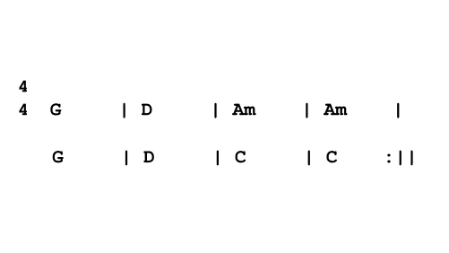
Don’t worry about timing and strum patterns at this stage just smooth out the changes..
5
[Cut to Nick Plus Guitar with 16to9_ knockingsequence .jpg as PIP]

Demo
One hit per bar until you have the changes down cold.

[Cut to Nick Plus Guitar]
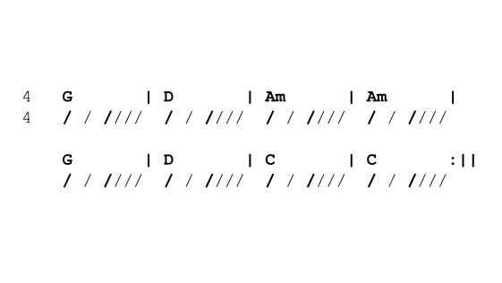
Now let’s look at the strumming pattern. Here’s one that strikes a good balance between being easy to do and sounding right for the song:
[Cut to 16to9_ knockingstrumpat.jpg]
Notice the diagonal lines under the chord symbols. This pattern is achieved with a mix of down strokes and upstrokes like this:

6
[Cut to RIGHT and with 16to9_ knockingstrumpat.jpg as PIP]
Demo
Down, Down, Down Up Down Up
Just practice that for a while without changing – just on the G chord.
Demo
[Cut to Nick Plus Guitar]
Then without letting up with the right hand try and superimpose the rest of the changes with the left hand..
Demo
G D Am Am G D C C…
Keep going .. steady as you can.

[Nick head and shoulders]
This might take a fair amount of practice to get smooth. If your struggling, the trick is to go back a step and work more on the left hand shape changes. Home in on the chords that give you the most problem and practice changing to them as many times as possible.

The right hand only ever be as good as the left!
7
[Cut to Nick Plus Guitar]
Ok now we’ll play out with a full performance. Hope you have enjoyed learning this great song and that you’ll join me in another lesson in this easy acoustic song series soon..

Okay see if you can play along with me…

1 2 3 4
Demo
Vs Ch Vs Ch Vs Ch Ch Ending

================================================================

