1
3.1 Classic Guitar Intros and Riffs – Intro to Layla by Derek and the Dominoes

[Open with 16to9_IntroLayla.jpg]
[Attach soundfile: SGT_IntroLayla.wav]

[Nick head and shoulders]
Amazingly Layla never made the charts when it was first released in 1970, but two years later it was released again and went to number 7. It has since frequently made it onto lists of the greatest guitar tunes of all time. I think it’s a truly great song.

2
[Cut to Nick Plus Guitar]

Listening to the original it is worth bearing in mind that part of the guitar sound comes from Duane Allman’s slide playing mixed very tightly to Clapton’s lead guitar. So emulating the exact sound is not really an option.

You can still do the song justice by selecting the bridge pick-up, and then really get as much signal to your speakers as you can.

[Cut to Guitar controls]
Turn the volume and tone all the way up on the guitar, then on your amp ….

[Cut to Amp controls]
Use the overdrive, boost or distortion channel and set up with the output amp volume turned down while you crank up the gain at the input end of the signal path. I also crank up the bass middle and treble pots to allow the fullest sound possible.
3
[Cut to Nick Plus Guitar]
Now if all that sounded a bit technical don’t worry. As long as you can get a good overdrive sound you’ll be ok. If you’re not sure about how to do that with your amp and guitar then check the lesson on ‘How to play the Amplifier’

OK we’re ready to roll. Here’s the tab for the opening bit this is like an intro to the intro:
[Cut to 16to9_TabIntroLayla_1.jpg]
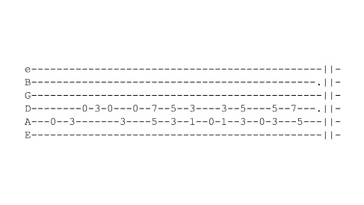
This has got two parts really – the fast opening line followed by the power chords.

Here’s how to do the fast bit:

4
[Cut to left hand]
Demo

(Talk through)

You have two choices. If your picking speed is really good then pick every note.

[Cut to RIGHT hand]
Demo

Notice I am producing seven notes with seven pick movements:
Demo
But for most of us there is a good cheat that will get you playing the lick up to speed quicker. Using hammer-ons and pull-offs
Demo
Now I am producing seven notes with just three pick movements:
Demo
Good cheat eh?
Here’s the trick:

5
[Cut to left hand]

Demo
(Explain)

[Cut to Nick Plus Guitar]
If you practice it using that cheat you can always work up to the other way of playing it, because at least your left hand will be getting used to the speed of movement required.

Now the power chord bit:
[Cut to left hand]
Demo

[Cut to Nick Plus Guitar]
It’s quite a trick. It’s going to take most guitarists a lot of practice to transition smoothly from the open lead phrase to the chords. One trick is to have someone else play the chords!

Another trick is to play one part and hum or sing the other like this.

Demo
6
Keeping your hand moving in time all the while.
Then swap parts:
Demo

Start out slow but rhythmic and gradually speed up.
Once you can do each part ok like this. Slow down again then try putting them together.
Demo

[Cut to Head and Shoulders]
Now the main part of the intro has four different lines to learn here’s the tab for the first line:

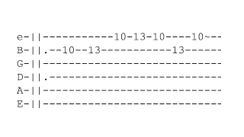
[Cut to 16to9_TabIntroLayla_2.jpg]

[Cut to left hand with 16to9_TabIntroLayla_2.jpg as PIP]
Demo
(Talk through)
Alternate picking for speed
7
[Cut to Head and Shoulders]
Now the second part:
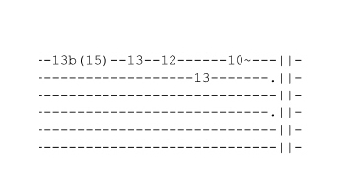
[Cut to 16to9_TabIntroLayla_3.jpg]

[Cut to left hand with 16to9_TabIntroLayla_3.jpg as PIP]
Demo
(Talk through)

Then after repeating the first line:
[Cut to 16to9_TabIntroLayla_2.jpg]

[Cut to left hand with 16to9_TabIntroLayla_2.jpg as PIP]
Demo

We then move up to the next position for the next part:
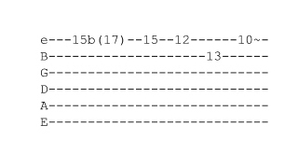
[Cut to 16to9_TabIntroLayla_4.jpg]
8
[Cut to left hand with 16to9_TabIntroLayla_4.jpg as PIP]
Demo
[Cut to left hand]
Then we repeat the first two parts again
Demo
Then we play a modified version of the second part that ends like this:
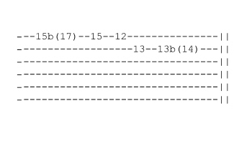
[Cut to 16to9_TabIntroLayla_5.jpg]
[Cut to left hand with 16to9_TabIntroLayla_5.jpg as PIP]
Demo
[Cut to Head and Shoulders]
That final note bent up to C# signifies a key change from Dm Intro E major verse. Ok here’s the whole Intro at slow speed:
[Cut to Left Hand]
Demo
[Cut to Head and Shoulders]
Hope you enjoyed that one. If you get stuck on any part of it just send me a question on it and I’ll be pleased to help out. See you next lesson
================================================================

