1
3.5 Classic Guitar Intros and Riffs – Intro to Hey Joe

[Open with 16to9_IntroHeyJoe.jpg]
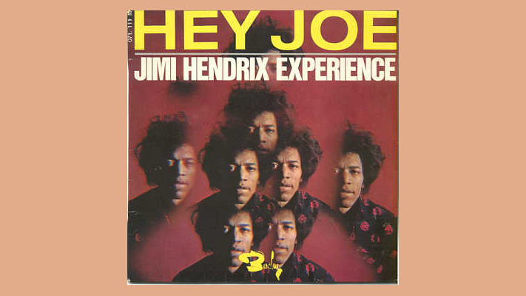
[Attach soundfile: SGT_IntroHeyJoe.wav]

[Nick head and shoulders]
Still thought by many to be the greatest guitarist that ever lived Jimi Hendrix recorded Hey Joe as his first single in 1966. I’d like to have a pound or even a dollar for every time I’ve heard a pub band cover this tune.

To get exactly the same sound as Jimi is close to impossible as he played a righthanded guitar upside down lefthanded and there’s no doubt that this helped give him a unique sound.

2
A strat played through a big marshall amp with the sound kept clean with a fair amount of reverb gets you close.

I’m just using my Ibanez Semi-Acoustic with the pick-up selector on neck pick-up.

Here’s the Tab
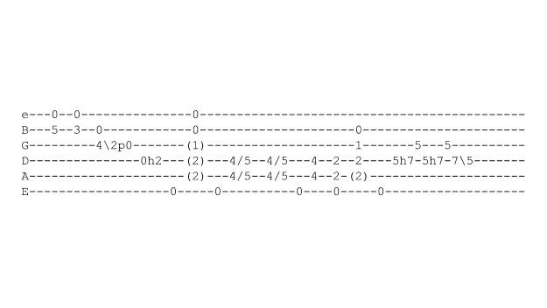
[Cut to 16to9_TabIntroHeyJoe.jpg]
You can see there are quite a few technical markings on this one, but don’t worry we’ll take it a step at a time and explain each bit as we go.

[Cut to left hand]

The first two chords are played across the top two strings, but only the B string is actually fretted fret 5 then 3
Demo

3
Now you have to make sure your finger on the B string doesn’t stop the open E string sounding as that’s a crucial part of the sound we’re after
Demo
[Cut to RIGHT hand]
On the Right hand I suggest playing with fingers or finger and thumb if you can.
Demo
Once you’ve learnt the intro you can experiment with various combinations of fingers and thumb to see what works best for you.
You can also play it with a pick, but you won’t get quite the same sound – still sounds pretty cool!
Demo

[Cut to 16to9_TabIntroHeyJoe.jpg]
The next lick includes a slide followed immediately by a pull-off. Note that the first note has the open B string added as well and this is allowed to ring as we complete the lick. Here it is played slowly:

4
[Cut to left hand]

Demo

This is how I suggest you practice this to start-off – nice and slow and deliberate, concentrating on getting a really clean sound from every note. Get that just right then its easy to build up the speed later.
Demo

[Cut to 16to9_TabIntroHeyJoe.jpg]

Now we come to the hammer-on on the D string at the second fret followed by the open E in the bass and the two open strings at the top of the E chord.

Note the shape of the E chord is in brackets – normally you would hold these notes down even though they are not sounded. This is best practiced together like this

5
[Cut to left hand]

Demo

If using fingers and thumb I strongly suggest using the thumb on the hammer-on, you can really hear this when Jimi plays it – its given extra emphasis
[Cut to RIGHT hand]
Demo
Ok. So take some time out to work at that first bar. For most people, unless you are well used to Jimi’s style, this takes quite a bit of practice to learn. I’ll leave the Tab up here for a few seconds. Pause the video if you’d like to take time out to practice that.
[Cut to 16to9_TabIntroHeyJoe.jpg]
5 secs……

6
[Cut to Nick Plus Guitar]
The next bit works by playing the open E with your thumb while you slide the two chord notes up to fret 5 and take a double bite at that before bouncing off the bass note onto the chord notes at fret 4 and back to the E shape. Here it is played slow:

[Cut to left hand]

Demo

Next, let’s put together what we’ve got so far – still nice and slow
[Cut to left hand with 16to9_TabIntroHeyJoe.jpg as PIP]

Demo

Again, I suggest taking time out to practise that, before tackling the final phrase

7
[Cut to 16to9_TabIntroHeyJoe.jpg]

5 secs….

And lastly we bounce off the open E bass note once again and then leap up to fret 7 and 9 for the fast hammer on lick that leads into the opening C chord of the verse

[Cut to left hand with 16to9_TabIntroHeyJoe.jpg as PIP]
Demo
Notice that the hammer-on lick repeats itself but the accent shifts..
Demo

[Cut to Nick Plus Guitar]

Ok so here’s the whole Intro played nice and slow

[Cut to left hand with 16to9_TabIntroHeyJoe.jpg as PIP]
Demo

8
[Cut to RIGHT hand with 16to9_TabIntroHeyJoe.jpg as PIP]
And the Right Hand view

Demo
[Cut to Nick Plus Guitar]
And more or less at speed..

Demo

Hope that’s helped you get that one down! Don’t worry if it takes a fair amount of practice to get that right – It took me quite a while too!

See you again soon!

================================================================

