1
3.4 Classic Guitar Intros and Riffs – Intro to Sultans of Swing by Dire Straits
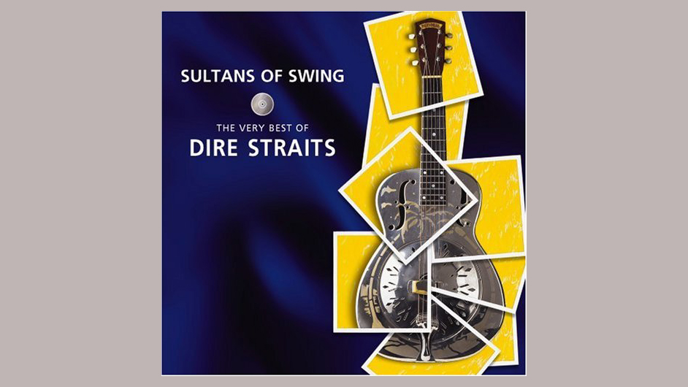
[Open with 16to9_SultansOfSwing.jpg]

[Attach soundfile: SGT_ IntroSultansOfSwing.wav]

[Nick head and shoulders]
Back in the late seventies I remember being knocked out by this song when it first came out. So let’s have a look at how this intro is played…

[Cut to Nick Plus Guitar]

If you want the exact sound from the record you’ll need to play it on a fender strat. Legend has it that Mark Knopfler used 8 gauge strings in those days and my best guess is the pick-up selector was on middle and neck to get that warm tone although it might have been middle

2
and bridge with the tone rolled off. Experiment!

I don’t have a strat handy so I’m going to use my faithful Ibanez with the neck pick-up selected.

Here’s the tab
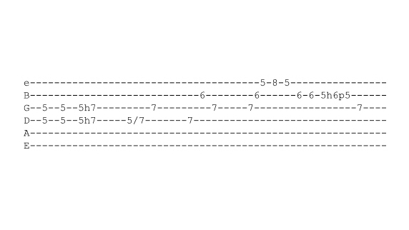
[Cut to 16to9_TabIntroSultansOfSwing.jpg]
…5 secs
Let’s look at the left hand first
[Cut to left hand with 16to9_ TabIntroSultansOfSwing.jpg as PIP]
Starts with a double stop hammer on from 5 to 7 on the middle two strings

Demo

With right hand we need to be using thumb and fingers if we want to get close to the original feel, but it works pretty good with a pick as well
3
[Cut to RIGHT hand with 16to9_ TabIntroSultansOfSwing.jpg as PIP]

Demo

[Cut to left hand with 16to9_ TabIntroSultansOfSwing.jpg as PIP]
Next phrase uses a slide from 5 to 7 fret on the D string then adds the note at 7 on the G string. Start the slide on the third finger like this

Demo

On the right hand I advise using thumb and index finger like this

[Cut to RIGHT hand with 16to9_ TabIntroSultansOfSwing.jpg as PIP]
Demo
Good idea to repeat that bit a few times before moving on…

[Cut to 16to9_TabIntroSultansOfSwing.jpg]
…5 secs
4
[Cut to left hand with 16to9_ TabIntroSultansOfSwing.jpg as PIP]

Now we come to a slightly more technical bit. The next three notes are played on three different strings and are quite quick
Here’s the left hand…
Demo

And the right hand view

[Cut to RIGHT hand with 16to9_ TabIntroSultansOfSwing.jpg as PIP]
Demo

[Cut to Nick Plus Guitar]

So far then we have
Demo

Then we have these three notes of the D minor chord played very quickly like this:
[Cut to left hand with 16to9_ TabIntroSultansOfSwing.jpg as PIP]
Demo

This is done with the thumb, index and middle finger working together
5
[Cut to RIGHT hand with 16to9_ TabIntroSultansOfSwing.jpg as PIP]
Demo
[Cut to Nick Plus Guitar]
This requires good coordination and may take a while to come together.
One tip is to set both hands up well in advance like this
Demo

Also, if needed, experiment with the amount of contact on the right hand fingers. If your fingers are getting a bit stuck..

[Cut to RIGHT hand with 16to9_ TabIntroSultansOfSwing.jpg as PIP]
Demo
Then lighten your touch. Think rotate wrist.

After this the little finger finds the note at the 8th fret on the top string and we come back down the min7th arpeggio like this

6
[Cut to left hand with 16to9_ TabIntroSultansOfSwing.jpg as PIP]
Demo
Before finishing with a bounce lick between the 5th and 6th frets on the B string and resolving on the key note D at fret 7 on the G string

Demo
[Cut to Nick Plus Guitar]

We’ll stick the tab up on the screen for a few seconds now and if you’d like to pause the video and work over that a few times you can. Once you’re ready come back to join me in a run through of the whole intro:
[Cut to 16to9_TabIntroSultansOfSwing.jpg]
…5 secs

[Cut to Nick Plus Guitar]
Ok here it is at slow speed
Demo
And somewhere around normal speed
Demo

7
[Cut to Head and Shoulders]

That’s another famous intro done and dusted! Remember to let us know if there’s an intro or riff that you’d like to learn that we haven’t covered yet.
See you again soon!
================================================================

