1
3.1 Classic Guitar Intros and Riffs – Intro to Sunshine of Your Love by Cream
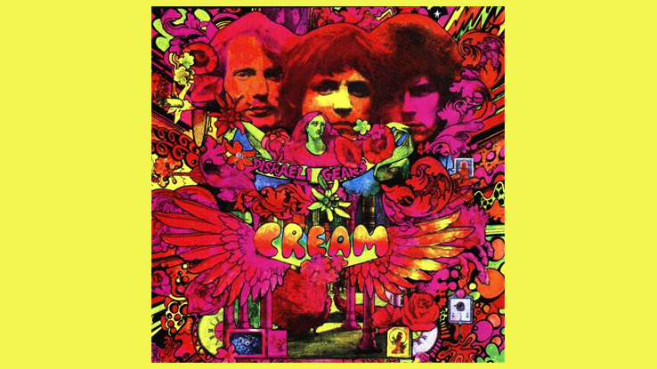
[Open with 16to9_IntroSunshineOfYourLove.jpg]

[Attach soundfile SGT_IntroSunshineOfYourLove.wav]

[Nick head and shoulders]

This song was first recorded around 1968 and featured Eric Clapton on Guitar with Jack Bruce and Ginger Baker making up the supergroup Cream.

First a word about the tone of the guitar on the original recording. It was played on a Gibson SG through a Marshall Amp but had most of the top end of the tone stripped out. One popular theory is that this was done using a wah pedal fully open in the bass position.

2
[Cut to Nick plus Guitar]
Now we can emulate the tone close enough by playing any electric guitar through an amp set up to play with a bit of overdrive or distortion and then selecting the neck pick-up position and winding the tone knob all the way off to suppress the treble. Like this:

[Cut to Amp]
Demo
[Cut to Guitar Pick-ups and tone knobs]
Demo

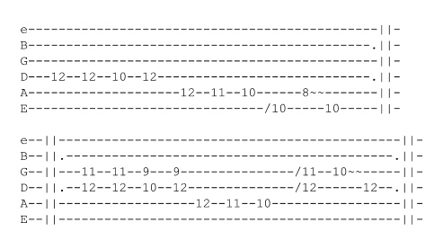
OK so let’s look at the tab

[Cut to 16to9_TabIntroSunshineOfYour.jpg] 5 secs

You can see there are two lines, both of which are repeated.

Let’s take line one first:

3

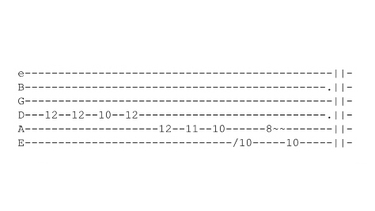
[Cut to 16to9_TabSunshineLine_1.jpg]

[Cut to left hand with 16to9_TabSunshineLine_1.jpg as PIP]

Start on 12th fret on D string 3rd finger
Play the first two notes then hit the same string fret 10 with first finger and back to first note.

Demo

Notice the staccato way these notes are sounded this means lifting the string off the fret on the last note pretty smartly

[Cut to close-up of left hand]
Demo

This is followed by three more staccato notes played on the off-beat like this

4
[Cut to left hand with 16to9_TabSunshineLine_1.jpg as PIP]
Demo
On the 5th string frets 12 11 and 10

Then we come down a position and use 3rd finger to slide into the 6th string at fret 10 and follow this with a slight vibrato on 5th string at fret 8 like this:
Demo
And back to the key note at fret 10 on the 6th string
Demo
whole line:
Demo

[Cut to Nick Plus Guitar]
Practice that a few times until it’s easy, because the next line is a little harder to play. Here’s the tab again

[Cut to 16to9_TabSunshineLine_1.jpg] … for 5 secs

[Cut to Nick Plus Guitar]
Okay so on to the next line

5
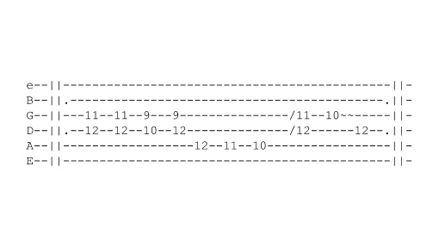
[Cut to 16to9_TabSunshineLine_2.jpg] … for 5 secs

[Cut to left hand with16to9_TabSunshineLine_2.jpg as PIP]
Starts with a double stop best played with second and third fingers at frets 11 and 12 on the G and D strings like this:
Demo
This then jumps down a couple of frets and back again mirroring the riff in the first line except with two-note chords instead of single notes
Demo
The next three notes are identical to those played in the first line at this point – 12 11 and 10 on the 5th string played on the off-beat.
Demo
Then we are back to our double stop at 11 and 12 on the G and D string with a little slide into it this time..
Demo
6
Then a vibrato played on fret 10 on the G string resolving back to the key note this time at fret 12 on the D string
Demo
So the whole line looks like this:
Demo
And at half speed..
Demo

[Cut to Nick Plus Guitar]
Okay so have a good go at practicing that and once you have it down have a go at playing the whole intro along with me at slow-speed: Remember we play each line twice
1 2 3 4
Demo
[Cut to Head and Shoulders]

OK hope you enjoyed that one and remember to let us have your comments and requests for more lessons. See you again soon

================================================================

