1
2.7 Guitar Gym – String Skippers

[Nick head and shoulders]
Ever have the problem that you are playing different notes but they all sound the same:
Demo
Then you suddenly realise that your right hand isn’t picking the same string that your left hand is fretting!
Demo
Good guitar playing requires very fine co-ordination of the two hands and this doesn’t just happen overnight for most people.
The good news is that the process of improving co-ordination can be greatly accelerated by specific exercises that you can find here in the Gym.

The first exercise that helps mainly in this way is the string skipping exercise and in this lesson we’ll look at two of these.

First the Easier one. Here’s the tab:
2
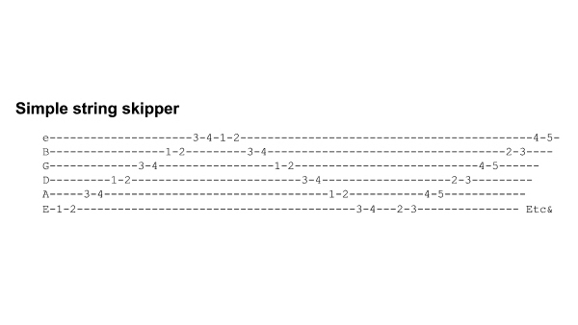
[Cut to 16to9_SimpleStringSkipper.jpg]

You can see the basic idea is similar to the easy warm-up drill that we covered in the Guitar Gym Induction Lesson, but the difference is that we are moving more vertically across the strings.

Let’s see if we can do this together at 80- bpm

[Cut to left hand]

Demo at 80bpm 1 npb

As we speed the exercise up you’ll find that it works quite well at 2 notes per beat. Here it is again with the metronome at 120 bpm playing 2 notes per beat.

Demo at 120bpmx2npb

3
[Cut to Head and Shoulders]

I strongly suggest getting this string skipper up to that sort of speed before tackling the more advanced one.

The harder string skipper isn’t so much harder to play – it’s just harder to learn the correct sequence…you’ll find you need a high level of concentration to get this right!

Here’s the tab:
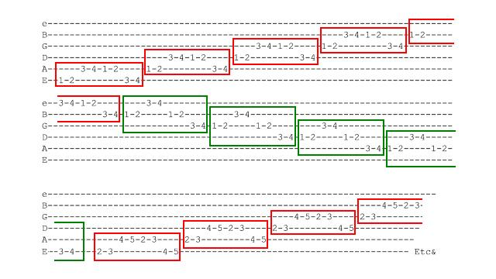
[Cut to 16to9_HarderStringSkipper.jpg]

Notice that I have outlined groups of notes in RED and GREEN Boxes. This is to help overcome the difficulty of learning the sequence of notes.

4
First look at the RED boxes. This is the pattern we play on the way up the exercise as we move across the strings from the low E to the High E string:

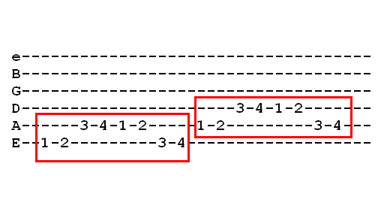
[Cut to left hand with 16to9_HarderStringSkipperAs.jpg as PIP]
Demo
Dividing the notes in this way ties in with what we hear as we play (Demo vocally)

We repeat this pattern until we have included the top string in it:

Demo

Then switch to the descending pattern – the one marked in green:

5
[Cut to left hand with 16to9_HarderStringSkipperDesc.jpg as PIP]
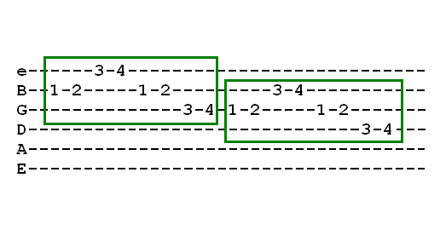
Demo
This is a different pattern, but to your ear it sounds similar to the ascending pattern. It is interesting that for most musicians aligning their memory to what they hear is a better bet than aligning it to a visual pattern.

Now we repeat this pattern all the way down to the 6th string, then, we get back to the ascending pattern, but move everything up a fret:
Demo

6
[Cut to Head and Shoulders]
If you find this at all difficult I strongly recommend you practice the patterns separately. Focus in on just the ascending pattern (RED) to start with and make sure you can do that and recognise its sound.

Then work on the DESCending pattern (Green) and polish that one off.

Then, when you can do those easily at 80bpm one note per beat then join me in this demo of the whole exercise:

[Cut to Nick Plus Guitar and metronome]
Demo at 80bpm 1npb
Once you get this up to faster speeds it works great at 2 notes per beat.

I’m going to play out now at a setting of 120bpm at 2 notes per beat to demonstrate. See you again soon.
================================================================

