1
2.1 Using Phrases from Texas blues to Improvise – verse six
[Nick head and shoulders]
Intro:
Now to the final verse of Texas Blues and the Fifth Position Blues scale.

In this lesson we’ll take a closer look at this position and also some nice techniques that combine doublestops’ slides and hammer-ons.

First Here’s the scale pattern:

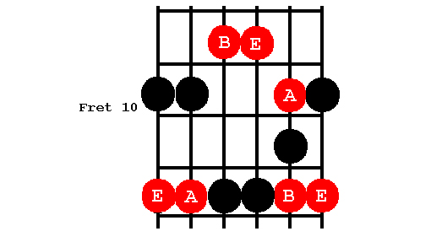
[Cut to 16to9_BluesScale_14.jpg]

And how to drill it:

[Cut to left hand with 16to9_BluesScale_14.jpg as PIP]
Demo
Start second finger – one finger per fret

2
[Cut to Nick Plus Guitar]
In this lesson we are going to concentrate on using the top half of the scale.

[Cut to 16to9_BluesScale_15.jpg]
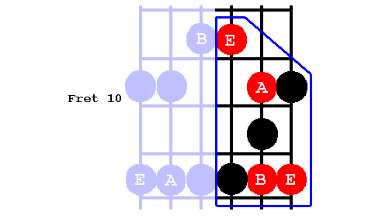

In Texas Blues verse 6 we used a phrase based on bouncing these two notes off each other

[Cut to left hand with 16to9_BluesScale_15.jpg as PIP]

Demo tex blues vs.6

Here’s a nice versatile lick you can use to extend this idea a bit further:

3
[Cut to left hand with 16to9_tabTexBlues_22.jpg as PIP]
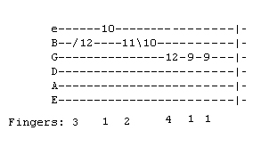
Demo lick
Pay special attention to the fingering (Demo)

[Cut to Nick Plus Guitar]

Once learnt try pairing this with the Texas Blues lick like this:

Demo lick pairing

[Cut to Head and Shoulders]
Now here’s another nice lick from this area:

4
[Cut to left hand with 16to9_tabTexBlues_23.jpg as PIP]
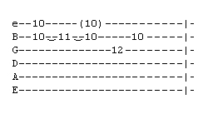
Demo lick

Note trick of letting the top string ring (brackets on the tab)
Makes a real bluesy sound
Demo

[Cut to Nick Plus Guitar]

Using these three ideas in the context of the Texas Blues chords can really help you develop your improvised use of the fifth position.

Basically use each lick as a starter and experiment with other notes in the scale to mould licks to suit the changes. Something like this:

Demo Texas Blues with added licks

5
[Cut to Head and Shoulders]

Once you have got the hang of that you can recycle the same ideas against other blues backings. Like the 12- bar in E Backing Track that you’ll find on the tool bar next to this lesson.

Hope you enjoyed this series of lessons on using the Texas Blues to develop improvising skills.

I’m going to play out now using the Texas Blues licks as my starting point but also exploring some of the extra ideas we have discussed in this series.

Look forward to joining you on whatever course you choose to take next!

Cue BT (12 bar in e)

================================================================

