1
2.0 Using Phrases from Texas blues to Improvise – verse five

[Nick head and shoulders]

Intro:
This lesson introduces the Fourth Position Blues scale pattern. One of the most versatile areas of the scale patterns and the second-most commonly used.

We’ll also have a look at a great technique that combines double stops with bends to produce another classic blues sound that might remind you of an old steam train whistle.

Here’s the scale pattern:
[Cut to 16to9_BluesScale_11.jpg]

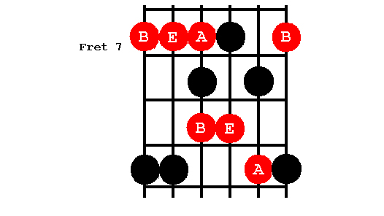

2
Best way to drill this pattern is using the normal one-finger-per-fret rule like this:

[Cut to left hand with 16to9_BluesScale_11.jpg as PIP]
Demo

[Cut to Nick Plus Guitar]
If you are not already familiar with this then spend a bit of time getting to know it because it is a pattern that confuses people!

As with previous patterns there are particular segments that are worth homing in on – have a look at this:

[Cut to 16to9_BluesScale_12.jpg]

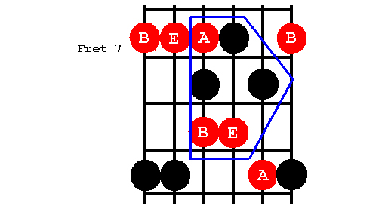

3
Here are a few ideas that come from this segment, see if you can copy some of them and then make up some more of your own:

[Cut to left hand with 16to9_BluesScale_12.jpg as PIP]

Demo including ‘Purple Haze’

[Cut to Nick Plus Guitar]
Did you spot the Jimi Hendrix Lick in there?

Using the scale pattern like this we naturally align first finger with 7th fret.

A whole new set of possibilities arises from shifting our hand position up a fret so that our first finger is aligned with the 8th fret

Demo

This helps us better access this part of the pattern:
4
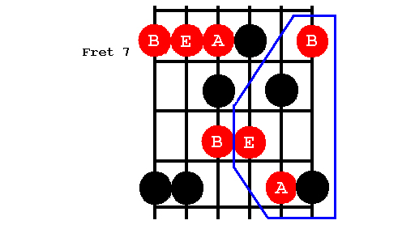
[Cut to 16to9_BluesScale_13.jpg]

Have a look at some of these ideas:

[Cut to left hand with 16to9_BluesScale_13.jpg as PIP]

Demo

[Cut to Head and Shoulders]

Now let’s listen to how all these ideas fit against the 12-bar blues backing track.

I’m going to repeat each idea a few times – see if you can copy some of them and then go on to make up a few of your own. Don’t worry if your ideas don’t all sound brilliant – remember learning to improvise is very much a trial and error process.

First we’ll line up with the first finger at fret 7:

5
[Cut to left hand with 16to9_BluesScale_12.jpg as PIP]
Cue BT (12 bar in e)
Demo first couple of verses using the first alignment

Now fret 8:

[Change PIP to 16to9_BluesScale_13.jpg as PIP]
then a couple of verses using the second alignment

[Cut to Head and Shoulders]

Go over that as many times as you like before moving on to the final part of this lesson.
…
Lets have a look at a nice variation on the original verse 5 of Texas Blues.

Remember how we played that?
[Cut to left hand]
Demo original verse 5
[Cut to Nick Plus Guitar]
Now instead of separating out the first two notes try playing them as a double stop like this:
6
[Cut to left hand]
Demo double stop
Have a close look at the right hand picking action on this:

[Cut to right hand]
Demo double stop with pick
Note downstrokes
- or if you pick with your bare fingers:
Demo double stop with fingers

[Cut to Nick Plus Guitar]
This technique can often be used wherever a phrase is made up of a bend followed by a note on a different string.

For example if we take a second look at the top end of the fourth position blues scale we were looking at just now:

[Cut to 16to9_BluesScale_13.jpg]
Here’s a couple of licks I might play using a bend on the B string at the 10th fret :

7
[Cut to left hand with 16to9_BluesScale_13.jpg as PIP]
Demo unison and 10th fret licks

Have a go at these licks yourself

Repeat Demo

But as a variation I can play them as double stops like this

Demo

The trick is to keep this finger solid while you push this one away from it. Have a go. Remember to strike firmly through both strings with your pick

[Cut to right hand]
Demo picking doublestop

Or pluck them with two fingers:

Demo fingerpicking doublestop

8
[Cut to Head and Shoulders]
So there’s quite a few ideas to work on using that fourth position blues scale.

Play around with these ideas either over the 12 bar blues in E backing track or the Texas Blues Backing Track. Tool bar at side of this screen or direct from the main menu – just click on Backing Tracks.

I’ll play out now using double stop bends against the Texas Blues B/Track. Copy some of these ideas, then create variations of your own.

See you again in the next lesson - last verse of Texas Blues - Fifth position B/Scale Patterns.

[Cut to left hand with 16to9_BluesScale_13.jpg as PIP]
Cue BT (Texas Blues)
Demo doublestop bends

================================================================

