1
1.9 Using Phrases from Texas blues to Improvise – verse four

[Nick head and shoulders]
Intro:
Verse 4 uses notes from the top end of the third position blues scale in E

This lesson looks at two things:

Viewing the third position as two separate halves and using the Unison Bend to form different licks.

First let’s look at the scale diagram :

[Cut to 16to9_BluesScale_7.jpg]
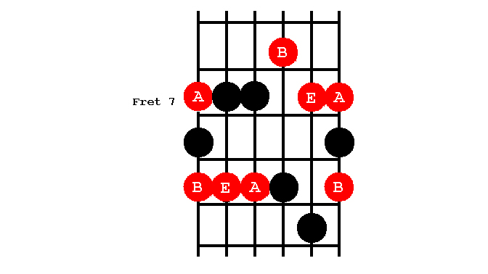
This is one of the trickier positions to drill as it requires a shift of hand position half way.

2
[Cut to left hand with 16to9_BluesScale_4.jpg as PIP]

Demo third pos. drill

Start on second finger
Then shift hand at B string

In practice most players tend to work this position as two separate areas:

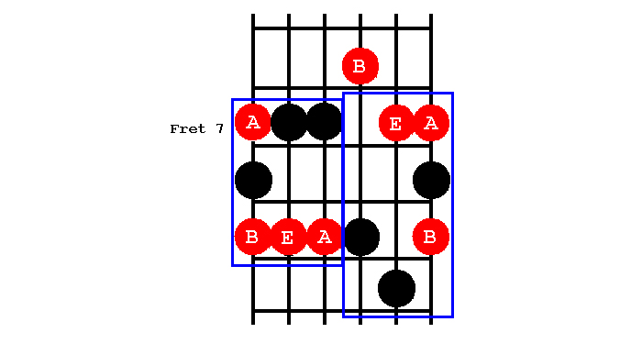
[Cut to 16to9_BluesScale_8.jpg]

The lower box on the E, A and D strings is an area of the guitar much used for classic rock and blues riffs.

See if you can find these:

[Cut to left hand]

3
Demo:
Sunshine of your love
Black Knight
Whole lotta love
Hoochie Coochie

It’s a great area for improvising with, as you have easy access to so many root notes and it’s all played on the strongest fingers. Here’s how I might use this area:
Cue BT (12 barin e) and
Demo

If you haven’t already explored this area I suggest you pause the video right now and spend a bit of time jamming over the
12-bar backing track (from the toolbar at the right of this screen). We’ll leave the scale diagram up on screen for a few seconds to help:

[Cut to 16to9_BluesScale_9.jpg]
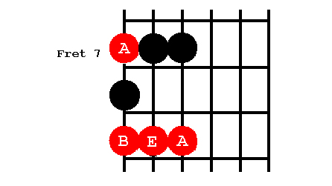
Pause 5 seconds
4
[Cut to Head and Shoulders]
Now switch attention to the top box in third position. This is where our verse 4 from Texas Blues is Played

[Cut to left hand with 16to9_BluesScale_10.jpg as PIP]

Demo Texas Blues Verse 4

[Cut to Nick Plus Guitar]
Now a crucial part of this phrasing is the opening bend:
Demo
Called a unison bend
Unison means same pitch
Tune the note by bending it

Notice that this requires a lot of strength
[Cut to left hand]

Demo
May require practice

[Cut to Nick Plus Guitar]

5
Once you’ve got this technique have a go at using it, together with the other notes from this part of the scale pattern to form a variety of phrases. Something Like this:

[Cut to left hand]
Demo

[Cut to Nick Plus Guitar]
Once you have developed a few ideas have a go at using them against the backing track. Use your ears to choose the end notes to suit the chord changes. Here’s a demo:
[Cut to left hand]
Cue Btrack 12 bar in e
Demo

6
[Cut to Head and Shoulders]
How to practice

If you are struggling with the unison bend or finding it hard to get fluency I recommend spending some time in the Guitar Gym you’ll see a link to this section of the site in the toolbox. Here you’ll find a number of exercises aimed at increasing finger strength, fluency, speed and co-ordination.

As always, drill the scales – you can never do too much scale drilling!

Then hours of jamming along to the backing tracks.

Have fun with all of that and I’ll catch you in the next lesson when we’ll look at grabbing some improvising ideas from verse 5 of Texas Blues.

================================================================

