1
1.8 Using Phrases from Texas blues to Improvise – verse three

[Nick head and shoulders]
Intro:
Verse 3 uses notes from the top end of the second position blues scale in E

This lesson look at two things:

Using the top end second position blues scale as extension to the first position
and
Using the slide as a really effective technique to make our phrases sound more authentic

First let’s look at the scale diagram :

[Cut to 16to9_BluesScale_3.jpg]
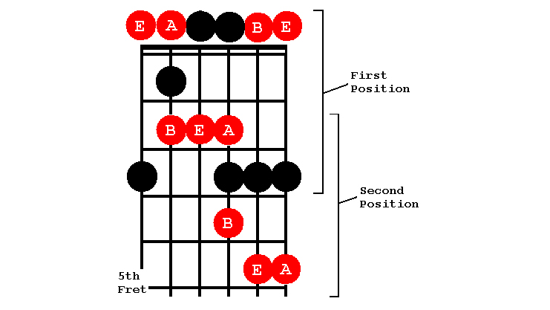
2
This looks a little complex at first glance but here’s a neat way of looking at it:

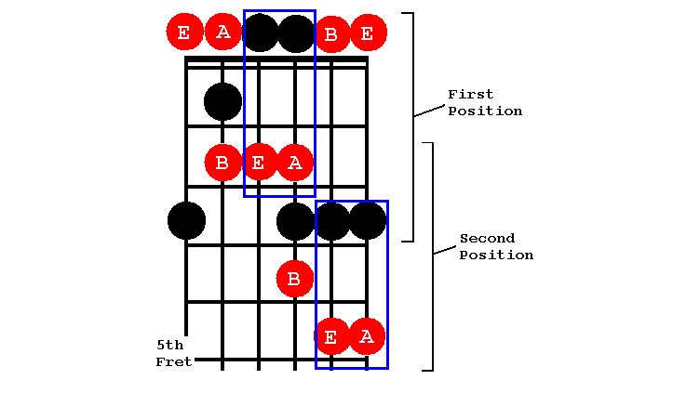
[Cut to 16to9_BluesScale_4.jpg]

Try and see these two boxes of notes in each of the positions. These are actually the same notes an octave apart. Listen to some of the ways we might use these two areas to echo phrases at different octaves:

[Cut to left hand with 16to9_BluesScale_4.jpg as PIP]

Demo Octave echoing

[Cut to Head and shoulders]
Once you have got used to thinking and playing in these two boxes then try using the three notes on the G string to link them.

3
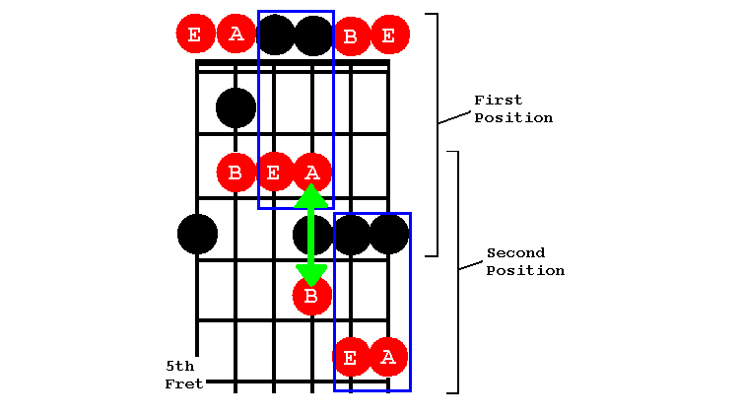
[Cut to 16to9_BluesScale_5.jpg]

Something like this:

[Cut to Left Hand with 16to9_BluesScale_5.jpg as PIP]
Demo Linking Boxes with three notes on G string

[Cut to Nick head and shoulders]

Spend a bit of time working between these two boxes and try to get your fingers making smooth easy transitions between first and second positions using the three connecting notes in between on the G string.

[Cut to Nick plus guitar]

4
Looking at verse three Texas Blues
Notice how it uses the slide to add a really authentic blues sound. This really is one of the great blues clichés. Here are some examples you may have heard:

[Cut to left hand ]

Demo : Dimples, SRV, Hey Joe
Baby Please don’t go

[Cut to Nick head and shoulders]

See if you can Make up some similar phrases using the slide in either direction as a starting point. Try to add other bits of technique, hammer-ons, pull-offs and bends where possible.

Here’s a rough idea of what I mean:

[Cut to left hand ]

Demo ad lib slide licks

[Cut to Nick head and shoulders]

5
Steal some of those if you like and invent a bunch of your own as well.

Once you have worked out a few ideas then move on to the next step:

[Cut to Nick plus guitar]

Now we try and put these ideas together against the 12 bar backing track

Working from the first to second positions and back again. Using the slide to connect our two boxes.

Something like this:
[Cut to left hand]

Cue backing track SGT06 12barine
Demo

[Cut to Head and Shoulders]
How to practice. Three things:

1. Drill the scale:
6
Here’s the whole of the second position:
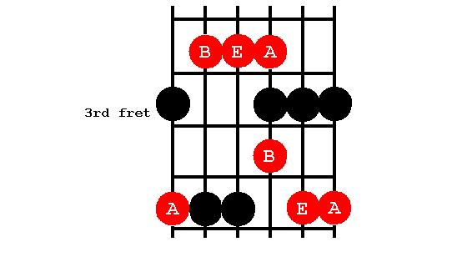
[Cut to 16to9_BluesScale_5.jpg]
And here’s how to drill this:
[Cut to Nick Plus Guitar]
Demo
Start on 2nd finger
Practice transition from first to second position

2. Listen to the blues greats: John Lee Hooker, Stevie Ray Vaughn

3. Doodle along to the backing track

Have fun and see you in the next lesson when we’ll look at what we can learn about blues improvising from Texas Blues verse 4

================================================================

