1
1.7 Using Phrases from Texas blues to Improvise – verse two

[Nick head and shoulders]
Intro:
Verse 2 uses just three notes.
These notes come from the top end of the first position blues scale in E

This lesson look at two things:

Using the first position blues scale
and
Making really effective phrases with very few notes

First let’s look at the scale diagram
[Cut to 16to9_BluesScale_2.jpg]
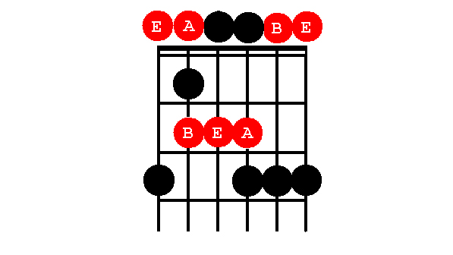
[Cut to Left Hand with 16to9_BluesScale_2.jpg as PIP]
Demo scale
2
[Cut to Nick head and shoulders]
If not already familiar, Take some time out to practice this and learn it off by heart

Look at verse two Texas Blues
Notice how it uses the open ‘E’ note to terminate almost all the phrases

[Cut to left hand with 16to9_BluesScale_2.jpg as PIP]
Demo terminating on E note
Except over the B7 chord – open B string
Demo terminating on B note

[Cut to Nick head and shoulders]
To phrase like this when improvising requires careful listening.

Make up some similar phrases that repeat simple note patterns until the chord change impels you to change the end note.

Let me show you what I mean against the 12 bar blues backing track …

3
I am going to repeat these phrases quite a few times so see if you can pick them up by watching and listening…

[Cut to left hand with 16to9_BluesScale_2.jpg as PIP]

Cue backing track SGT06 12barine

Demo repetitive phrases changing end notes when forced

[Cut to Head and Shoulders]
Just as we discovered in the previous lesson we can make more interesting phrases by alternating between resolved and unresolved phrases.

Remember that in this context resolved phrases end on root notes – unresolved phrases target the other notes of the scale.

It’s good practice to create pairs of phrases – one unresolved, the next resolved.
4
This is sometimes referred to as ‘Call and Response’ or ‘Question and Answer’ phrasing.

Here’s some examples – again we are going to play in a deliberately repetitive way so see if you can follow some of these ideas on your own guitar …

[Cut to left hand with 16to9_BluesScale_2.jpg as PIP]
Cue backing track SGT06 12barine

Demo alternating repetitive phrases resolved/unresolved

[Cut to Head and Shoulders]
How to practice.
Three things:

1. Drill the scale:

[Cut to Nick Plus Guitar]
Demo
Rhythmically with good quality
Up and down the scale

5
2. Listen to the blues greats: BB King, Albert King, Freddie King, Buddy Guy, Eric Clapton, Peter Green are some of my favourites…

3. Doodle:
That means just play experimentally. Mix in slides, hammer-ons, bends and pull-offs, vibrato technique.

I’ll play out with a demo of this – see how many of these phrases you can copy – steal licks is another great blues tradition!

Cue BT
Demo

================================================================

