1
1.6 Using Phrases from Texas blues to Improvise – verse one

[Nick head and shoulders]
Intro:
Blues phrasing is quite modular
Steal ideas from one thing and use them in another.

Texas Blues was deliberately written as a trainer

So let’s show you how to use it as a great starting point

Verse 1
Used a straightforward blues scale run
[Cut to Left Hand]
Demo scale
Each phrase carefully terminated on the root note of the chord that the phrase was anticipating
Demo terminating on root notes

2
So to use this scale intelligently it helps to be aware of where the three root notes are that belong to the chords used to play a typical 12-bar blues.

Picture the scale like this:

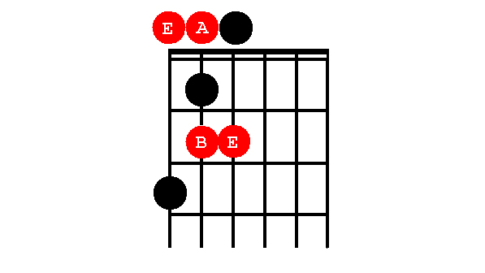
[Cut to 16to9_BluesScale_1.jpg]

Against an E chord (Major, Minor or 7th)
I can use the notes of this scale to create phrases that end on E like this:

[Cut to Nick Left Hand with 16to9_BluesScale_1.jpg as PIP]

Cue Btrack (E7)
Demo E phrases

[Cut to Nick plus guitar]
3
When the chord shifts to A7 I have the option to adjust my phrasing to terminate on the A note
[Cut to Nick Left Hand with 16to9_BluesScale_1.jpg as PIP]

Cue Btrack (A7)
Demo A phrases

Notice that you can terminate phrases on notes other than the root note, but they will sound less resolved.

For example - Over the E chord:

Cue Btrack (E7)
Demo E phrases unresolved

Or Over the A chord:
Cue Btrack (A7)
Demo A phrases unresolved

4
[Cut to Nick plus guitar]
When we get to the B7 chord things are generally a little more demanding and the root note really is the safest option here

[Cut to Nick Left Hand with 16to9_BluesScale_1.jpg as PIP]
Cue Btrack (B7)
Demo B phrases

[Cut to Nick Plus Guitar]
Generally speaking the art of good improvising is all about balancing phrases that resolve neatly with those that don’t.

As I play the following examples the chords will come up on the screen – see if you can spot how I mix resolved phrases with unresolved ones:
[Cut to Nick Left Hand with 16to9_BluesScale_1.jpg as PIP]
[Superimpose chord symbols on screen in time with changes per 16to9_12barine.jpg]
5
Too neatly resolved and things sound a bit tame:
Cue Btrack (12-bar)-Demo neat resolution

Too unresolved and things just sound too random:
Cue Btrack (12-bar)-Demo non-resolution

Balancing the two approaches:
Demo Balancing the two

[Cut to Nick Head and Shoulders]
Have a go.

To the right of the screen on the tools menu click on backing tracks.

First play the E7 Backing track and spend time working out a few licks that fit over the E chord.

Try some phrases that are deliberately resolved back to E and others that terminate on the other notes in the scale.

6
Once you have developed a few ideas do same thing over the A7 Backing track.

Use similar ideas but resolve back to the A note

Then over the B7 track -almost always going to want nice resolved phrases.

Then Play the 12-Bar Blues in E Backing track and put all your ideas together.

One last Important Point – don’t get frustrated - ‘You have to do it badly for many hours before you can do it well’

Practice a lot .

Have fun with that and I’ll see you in the next lesson when we’ll look at using verse 2 of Texas Blues to further develop your Blues Improvising Skills

================================================================

