1
1.3 Texas style blues – vs.4

[Nick head and shoulders]
Intro:
Verse 4 - again same chords different lead Introduces working further up the neck
[Cut to Nick Plus Guitar]
Cue BTrack
Demo Texas Blues Verse 4

First look at tab for first phrase
[Cut to 16to9_tabTexBlues_13.jpg]
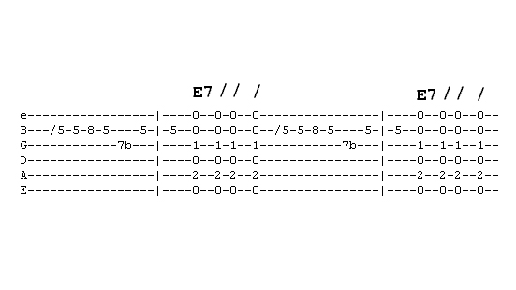
Start by skidding into fret 5 on the B string
Left hand with16to9_tabTexBlues_13.jpg as PIP]
Demo
Start on first finger
No time value added by slide
2
Repeat the note and add Pinky at 8th
Then back to the fifth fret
Demo
Then bend the note at fret 7 on the G string with your third finger
Demo
Then back to the E note on the B string at fret 5
Demo

[Cut to Nick plus Guitar]
Now it’s Quite a trick playing this and getting back to the open position for chords
Look first
Demo
Suggest pause and practice

Phrase two
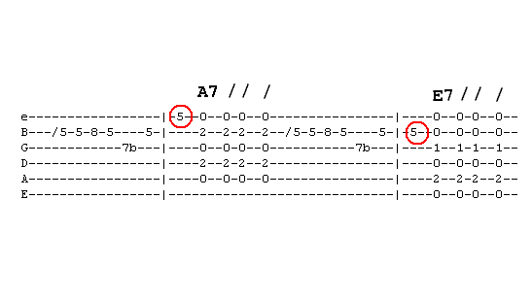
[Cut to 16to9_tabTexBlues_14.jpg]
3
See same phrase ending on 1st string
Ringed in red
This is an A note so leads nicely to the A chord
[Cut to Left hand with16to9_tabTexBlues_14.jpg as PIP]
Demo
Then it’s back to the original phrase for the E chord
Demo
For the B we don’t use the unison bend
[Cut to16to9_tabTexBlues_15.jpg]
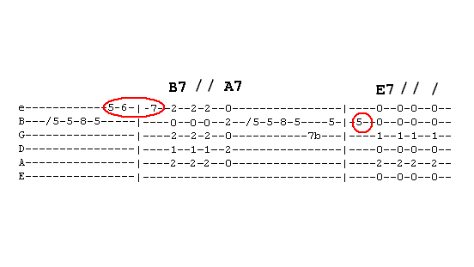
[Cut to Left hand with16to9_tabTexBlues_15.jpg as PIP]
But go straight into a run of three notes on the top string ending on the note B
Demo

4
Then jump back to play the B7 A7 change you may need to practice this a few times remember make eyes travel ahead
Demo
Have a practice – I’ll play it a few times – you copy
Demo Repeat Demo

[Cut to Nick plus guitar]
Now we’re ready to play the whole verse

Repeat demo with whole verse played faintly

Now you have learnt first four verses try putting it all together yourself
Here’s the backing track. I’ll play through with you on the first run through then leave you to it.
Cue Backing Track
Have fun with that and once you have got it down come back for verse five ================================================================

