1
1.2 Texas style blues – vs.3

[Nick head and shoulders]

Intro:
Verse 3 - again same chords different lead Introduces sliding and pull-off techniques

[Cut to Nick Plus Guitar]
Cue BTrack
Demo Texas Blues Verse 3

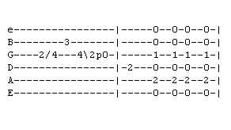
First look at tab for first phrase
[Cut to 16to9_tabTexBlues_9.jpg]
See the slash symbol between the figures 2 and 4 on the G string – that’s a slide

Start on second finger, Second fret on G string
2
[Cut to Left hand with16to9_tabTexBlues_9.jpg as PIP]
Demo slide

Then we add the note at fret 3 on the B string
Demo

Then we play slide in reverse

Few things to say about slides:
- Firmness
- Definite movement
- Fingering determined by next notes
- Timing

Have a practice – I’ll play it a few times – you copy
Demo Repeat Demo

[Cut to 16to9_tabTexBlues_9.jpg]
3
The next part of the phrase uses a pull-off. See ‘P’ for pull-off on tab

This looks like this:
[Cut to Left hand with16to9_tabTexBlues_9.jpg as PIP]

Demo pull-off
The string is played with the left hand..
Repeat Demo

We finish the phrase on the note E played on fret two on D string

Here’s the whole phrase:
Demo
Repeat Demo
And as in other verses - that is answered by the chords
Demo Chord call and response

Have a go! Let’s play this together a few times - You play the lead I’ll play the chords . come in after beat 1 like this
2 3 4 1
4
Demo timing
Demo playing faintly

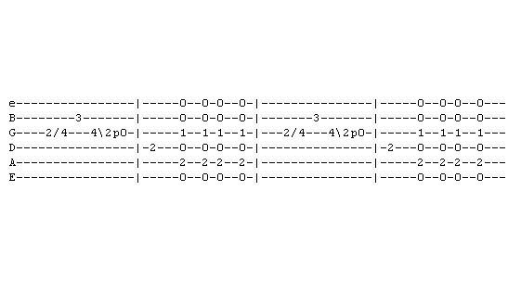
[Cut to 16to9_tabTexBlues_10.jpg]
You can see from the tab that this phrase is repeated to complete the first line.

Second line the same phrase terminates on the note A on the G string
[Cut to 16to9_tabTexBlues_11.jpg]
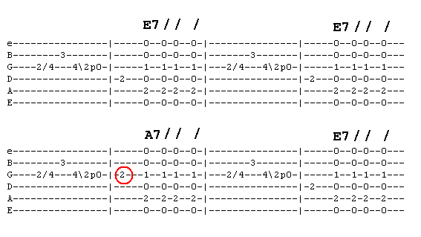
Then goes back to the first phrase to complete the line.
So here’s our first 8 bars – play along if you like :
[Cut to left hand with 16to9_tabTexBlues_11.jpg as PIP]
5
Demo

[Cut to Nick Head and Shoulders]
If you need a bit more time pause and practice before moving on.

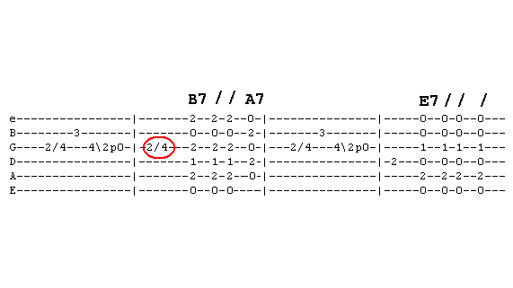
[Cut to 16to9_tabTexBlues_12.jpg]

The last line starts the same
but repeat slide from 2 to 4 on G string
to line up the B note to match the B7 chord like this
[Cut to left hand with 16to9_tabTexBlues_12.jpg as PIP]
Demo
Repeat demo with B7 – A7 change

Then it’s back to our opening phrase to complete the verse
Repeat demo with B7 – A7 – E change
6
[Cut to head and shoulders]
Have a few goes through this last line with me:
[Cut to left hand with 16to9_tabTexBlues_12.jpg as PIP]

Repeat demo with B7 – A7 – E change played faintly

[Cut to Nick plus guitar]
Now we’re ready to play the whole verse

Repeat demo with whole verse played faintly

Now you have learnt first three verses try putting it all together yourself
Here’s the backing track. I’ll play through with you on the first run through then leave you to it.
Cue Backing Track

7
Remember any time you want to practice that you can access the backing track from the toolbox menu

Have fun with that and once you have got it down come back for the next lesson when I’ll show you how to play verse four of Texas Blues.
================================================================

