1
0.5 How to Read Guitar Tab

[Nick Head and Shoulders]
Intro to Tab reading
- Special language for guitarists
-Takes a while to learn– like spoken languages
- This lesson will introduce you to the basics

Tab takes the strings of the guitar and represents them as six lines
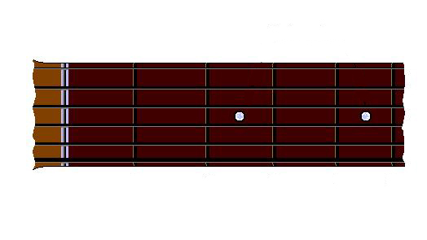
[Cut to 16to9_fretexp1.jpg]

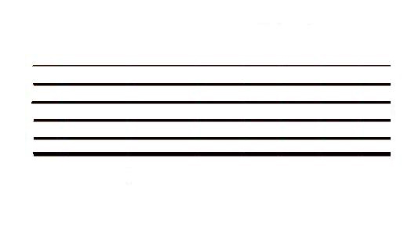
[Dissolve to 16to9_fretexp2.jpg]
[Dissolve to 16to9_fretexp3.jpg]
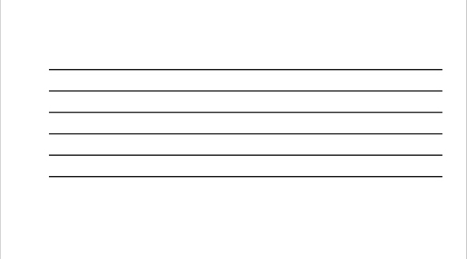
2
Sometimes (but not always) marked by open string note names which will usually be (Elephants and Donkeys…:

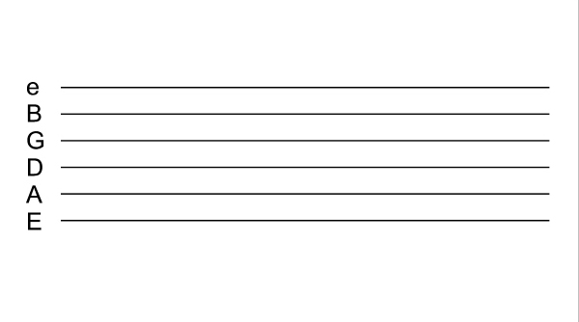
[Dissolve to 16to9_fretexp4.jpg]

[Cut to Nick plus guitar with 16to9_fretexp4.jpg as PIP]
People new to reading tab can easily get confused about which way up the lines are. The BOTTOM line always represents the bottom string. Remember that’s the lowest-sounding string!!

On this site we provide a further clue which is that the top E string is represented by a lower case e – but not everyone will be so kind!

The numbers placed on the lines tell you which fret to finger with the left hand.

3
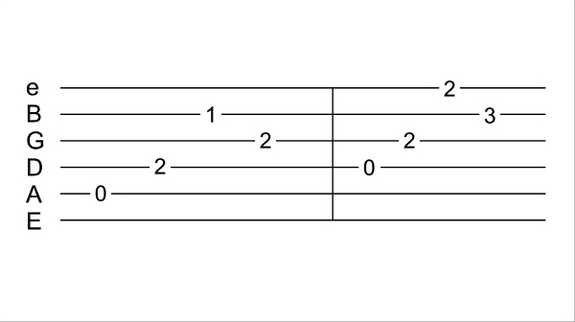
[Cut to 16to9_ fretexp5.jpg]
Now here is another point that sometimes throws people when they first try and understand tab …
Unlike chord diagrams, tab contains time which means that the numbers on the lines should be read sequentially from left to right.
So this tab tells us that the first thing to do is play the A string at fret Zero

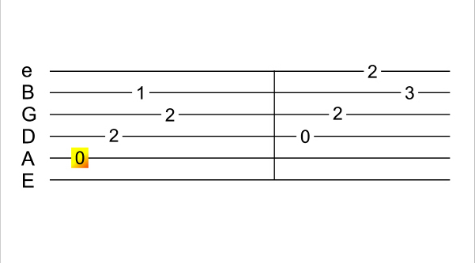
[Dissolve to 16to9_ fretexp6.jpg]

[Cut to Nick plus guitar with 16to9_fretexp6.jpg as PIP]
Zero means open string
Demo

4
[Dissolve pip to 16to9_ fretexp7.jpg]
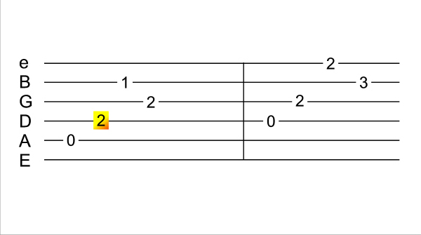
Next instruction is play the D string at fret 2
Demo
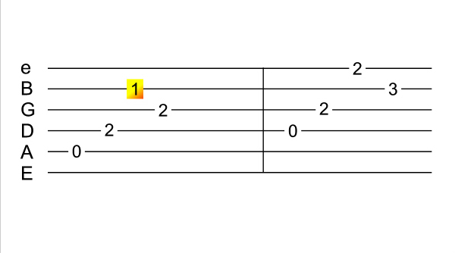
[Dissolve pip to 16to9_ fretexp8.jpg]
Then we play the B string at fret 1
Demo

[Dissolve pip to 16to9_ fretexp9.jpg]
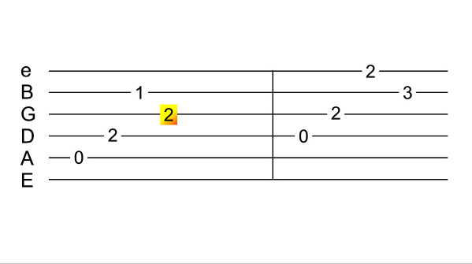
Followed by the G string at fret 2
Demo

And so on

5
[Nick Head and Shoulders]
So that is all there is to the basic process of reading tablature.
Remember the bottom string – the lowest sounding string - is represented on the tab by the bottom line.
And remember that time moves from left to right.

See if you can play both bars of tab yourself before we move on.. (pause the video)
[Cut to 16to9_ fretexp5.jpg]

Pause for 5 seconds

6
[Cut to Nick plus guitar with 16to9_ fretexp5.jpg as PIP]

Did it sound something like this?
Demo

If so then lets move on, if not then best to check back over the lesson to see where you went wrong.

Chords can look pretty scary in TAB form

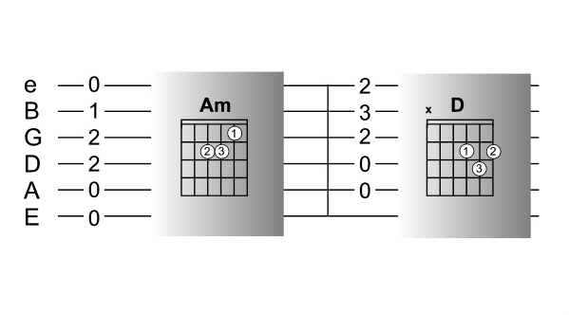
[Cut to 16to9_ fretexp10.jpg]
Here are two chords that you might be familiar with Am and D .

7
Most people would find the Grid diagram representation of the chord much easier to follow than the tab.

One trick is to mentally turn the grids through 90 degrees and ignore the finger numbers on the grid diagrams
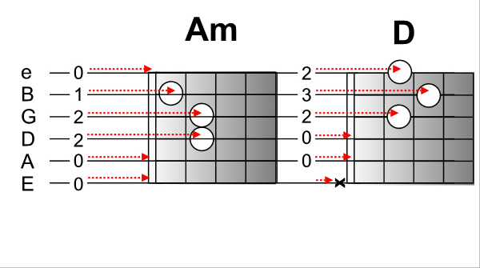
[Cut to 16to9_ fretexp12.jpg]

Then you can see how the numbers on the TAB direct you to place your fingers on the fretboard.

8
[Cut to Nick Head and Shoulders with 16to9_ fretexp12.jpg as PIP]

This ability to look at the numbers on the TAB and ‘SEE’ the shapes behind the numbers is a useful trick that will help you shortcut the TAB reading process.

For example, if we go back to our original TAB
[Cut to 16to9_ fretexp5.jpg]

Instead of fingering the notes one at a time like this..

[Cut to left hand with 16to9_ fretexp5.jpg as PIP]

Demo

If we look at each bar and see the shapes behind the numbers..

9
[Cut to 16to9_ fretexp11.jpg]
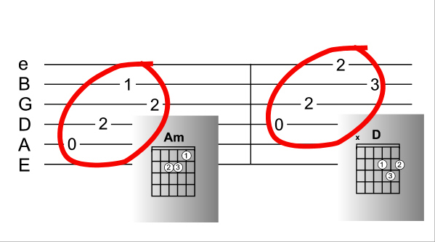
[Cut to left hand with16to9_ fretexp11.jpg as PIP]

We can just hold down the chord shape and concentrate on picking the strings in the correct order knowing that the chord shape will look after the fret numbers for us..
Demo

As many melodies and solos are based on chord shapes, this is a trick you will find useful to learn.

10
[Cut to Nick Head and Shoulders]
Many of the lessons on this site come with tabs that you can access by clicking on the printouts tab on the tool box to the right of the screen.

More advanced tab may include various symbols used to define technical details like bends, slides, hammer-ons etcc.

A key to these can be accessed from the reference tab on the main menu.

Ok, as always, any questions just ask!

See you in next lesson
=========================================

